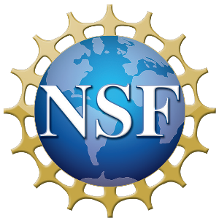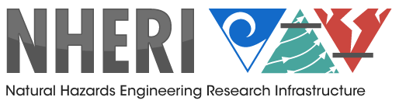

International Workshop to Develop Research Campaigns, Interdisciplinary Teams, and Disruptive Technologies for the NHERI 5-Year Science Plan for

Natural Hazards Engineering Research

March 18-19, 2019

Submitted to
Joy Pauschke, PhD, PE
Program Director
Engineering for Natural Hazards & Natural Hazards Engineering Research Infrastructure (NHERI)
Division of Civil, Mechanical, and Manufacturing Innovation
Directorate for Engineering, National Science Foundation

Issued: May 13, 2019

Table of Contents

March 18-19, 2019 1
Table of Contents 2
Executive Summary 5
Acknowledgements 7
Workshop Organizing Committee 7
Chairs 7
Committee Members 7
Introduction to the NHERI Science Plan 8
Three Grand Challenges 8
Key Research Questions 9
Workshop Objectives 10
Workshop Schedule 10
Development of Example Research Campaigns 11
Introduction 11
Campaign Development 12
Example Research Campaign for Earthquakes and Related Landslides 13
Resilience of Lifeline Systems 13
Research Challenge: 13
Intellectual Merit: 14
Broader Impacts: 14
Examples of Research Campaigns for Windstorms 16
Example 1: Immediate Occupancy of Low-Rise Buildings Following Windstorms 16
Research Challenge: 16
Intellectual Merit: 16
Broader Impacts: 17
Research Campaign Strategy: 17
Example 2: Mega-disasters 18
Intellectual Merit: 18
Broader Impacts: 18
Examples of Research Campaigns for Storm Surge and Tsunami in Coastal Areas 20
Example 1: Community-Level Management of Storm Surge and Tsunami Hazards 20
Research Challenge: 20
Intellectual Merit: 21
Broader Impacts: 21
Example 2: Comprehensive numerical simulation platform for hurricanes and tsunamis: from source to impact 21
Research Challenge: 21
Intellectual Merit: 22
Broader Impacts: 22
Summary and Next Steps 23
APPENDIX 1 24
Workshop Agenda 24
Westin-Alexandria, VA 24
APPENDIX 2 28
Workshop Participants 28
APPENDIX 3 31
Session Details 31
Social Science Perspective of the NHERI Science Plan 31
Expanding the Vision of Science and Engineering for the Natural Hazards
Community 32
Science of Team Science: Best Practices and Future Directions for Interdisciplinary Teams 32
Leveraging NSF ERC Funding with NHERI Facilities 34
A Vision for Future Hazard Mitigation/Disruptive Technologies Not Addressed in the NHERI Science Plan 35
Stephanie Paal, Assistant Professor, Texas A&M University. 35
Mike Gomez, Assistant Professor, University of Washington. 36
Simone Marras, Assistant Professor, New Jersey Institute of Technology 36
Ali Mostafavi, Assistant Professor, Texas A&M University 36
Allison Reilly, Assistant Professor, University of Maryland. 37
Will Srubar, Assistant Professor, University of Colorado Boulder 37
Disruptive Technologies 38
Role of Disruptive Technologies in reducing the impact of extreme events on communities 38
Workshop Breakout: Advanced Computational Methods and High-Performance
and Real-Time Computing 38
Notes on General Presentation 38
Notes on Advanced Discussion 38
Workshop Breakout: Data-Driven Science 39
Discussion questions: 40
Challenges: 40
Workshop Breakout: Robotics 42
Workshop Breakout: Bio-Inspired Design: 44
Introduction 44
Workshop Breakout: Additive Manufacturing 45
Part I presentation: 45
Part II discussion: 46
Workshop Breakout: Advanced Materials 47
Additional Technologies 48
Convergence Science 48
Science of Team Science (SciTS) 49
References 49
APPENDIX 4 50
Survey of Workshop Participants 50
Q1. The Workshop sessions explored innovative approaches for hazards and
disaster research. 51
Q2. The Workshop addressed unique opportunities and challenges of hazards
and disaster research. 52
Q3. The Workshop participants reflected a diversity of disciplines and
perspectives. 53
Q4. The Workshop provided an opportunity to form new collaborations within or outside my existing network(s). 54
Q5. The Workshop encouraged me to think about research campaigns in new or different ways. 55
Q6. The Workshop encouraged me to think about interdisciplinary teams in new or different ways. 56
Q10. Please share additional comments, questions, concerns, or suggestions here. 57
APPENDIX 5 58
Natural Hazards Engineering Research Infrastructure (NHERI) 58

Executive Summary

Civil infrastructure shelters and sustains individuals, families, and communities. This infrastructure is built on a network of facilities and services that include housing, schools, business, religious and cultural institutions, water, gas, electricity, sanitation, communications, and transportation, among others. All are interconnected and must be designed, constructed, and maintained with the expectation that they will provide adequate performance when subjected to effects of earthquakes, landslides, windstorms, and related natural hazards of tsunami and storm surge.

Failure of civil infrastructure adds considerable strain to communities and puts lives, health, economies, and vital societal functions at risk. The Natural Hazards Engineering Research Infrastructure (NHERI) is a distributed, multi-user, national network that provides the natural hazards engineering community with state-of-the-art research infrastructure ensuring that it has the well-coordinated testing and computational facilities required to meet the research challenges of the 21st century and achieve global leadership in natural hazard risk mitigation.

Funded by the National Science Foundation (NSF), NHERI enables researchers to explore and test ground-breaking concepts to protect people and the places where they live out their lives from earthquakes, landslides, windstorms, tsunamis, storm surges, and waves — enabling innovations to help prevent natural hazards from becoming societal disasters.

The NHERI Five-Year Science Plan is organized around three Grand Challenges, each with five Key Research Questions to guide NHERI research activities. The Science Plan provides the earthquake, wind, and coastal hazards engineering communities, including NSF and other federal and state agencies, a roadmap for high-impact, high-reward, hazards engineering research at NHERI facilities. The research results are intended to enable damage mitigation and prevent loss of life from natural hazards through delivery of technical breakthroughs to improve the resilience and sustainability of existing and future civil infrastructure, also known as the built environment. For each of the key research questions, high-priority research subject areas are also provided to assist future researchers in solving Grand Challenges. While the research plan is meant to provide guidance, it is also written in an open manner to ensure the ingenuity and creativity of the broader community is fully encouraged.

To provide a platform for incorporating these technologies into the network’s 5-Year Research Plan, the NHERI Network Coordination Office organized a 1.5-day workshop on March 18-19, 2019, in Alexandria, Virginia to advance the NHERI Five-Year Science Plan. More than 70 researchers participated—including early career and more senior academics from inside and outside the U.S., federal partners, private sector professionals, and representatives from the NSF.

The workshop had two main objectives: (a) Identify contributions from disruptive/transformational technologies to advance the NHERI Science Plan and the vision of NHERI; and (b) Develop potential research campaigns encompassing one or all of the natural hazards under the scope of NHERI.

To advance these two objectives, the workshop included researchers and industry leaders in the areas of transformational technologies including bio-inspired design, advanced computation, data science, materials science, additive manufacturing, robotics, and control theory to further the NHERI Science Plan’s vision of a more resilient and sustainable civil infrastructure.

In addition to the engineering community, the workshop highlighted contributions from social and behavioral scientists essential to advance the goals of the NHERI Science Plan to achieve resilient communities against natural hazards under the scope of NHERI. It catalyzed the formation of research teams and coordinated research campaign(s) nationally and internationally that will accelerate the pace of research and policy implementation towards improving the resilience of civil infrastructure through damage mitigation and prevention of loss of life from natural hazards. Participants also explored the science of team science, a new interdisciplinary field that empirically examines the processes by which large and small scientific teams, research centers, and institutes organize, communicate, and conduct research.

The main products derived from the workshop activities are as follows:

- This report documenting workshop findings and recommendations to be incorporated in the 5-Year and Beyond NHERI Science Plan to be published within four months following the event. The report includes five examples of research campaigns developed with input of participants from the NHERI community and substantive input from disruptive technology areas.
The research campaign examples fall under the following themes:
  - Earthquakes and Related Landslides: Resilience of Lifeline Systems;
  - Windstorms: Example 1 - Immediate Occupancy of Low-Rise Buildings Following Windstorms and Example 2- Mega-disasters;
  - Storm Surge and Tsunami in Coastal Areas: Example 1- Community-Level Management of Storm Surge and Tsunami Hazards, and Example 2: Comprehensive Numerical Simulation Platform for Hurricanes and Tsunamis: from Source to Impact.
- An online repository of the presentations during plenary and breakout sessions [LINK] and breakout discussions.
- In addition, members from the workshop organizing committee will write a journal article based on the findings of the workshop suitable for review and publication by organizations such as EERI, ASCE, and ACI.

Acknowledgements

We would like to express our deepest appreciation to the National Science Foundation for the support to make this workshop possible through a supplement to the NHERI-NCO Award CMMI-1612144. We give special thanks to the members of the Workshop Organizing Committee for their contributions, hard work, and dedication to the organization and implementation of this workshop. We would also like to acknowledge with much appreciation the crucial role of the keynote and plenary speakers, plenary panelists, and breakout session leads and participants, who shared their knowledge to contribute to advance the NHERI Science Plan.

Workshop Organizing Committee

Chairs
Julio A. Ramirez, Ph.D., Karl H. Kettelhut Professor in Civil Engineering and NHERI-NCO Center Director, Purdue University
Billy L. Edge, P.E., Ph.D., Dist. M. ASCE, Professor of Practice, Civil, Construction, and Environmental Engineering Department, North Carolina State University

Committee Members
Antonio Bobet, Sc.D., Professor of Civil Engineering, Purdue University
Ross Boulanger, Ph.D., N.A.E, Professor of Civil and Environmental Engineering, University of California Davis
Christopher Gill, Sc.D., Professor of Computer Science and Engineering, Washington University in St. Louis
William T. Holmes, S.E., N.A.E., Senior Consultant, Rutherford + Chekene Consulting Engineers
Jerome P. Lynch, Ph.D., Professor and Donald Malloure Department Chair, Department of Civil and Environmental Engineering, University of Michigan
Forrest Masters, Ph.D., Professor and Assoc. Dean for Research and Facilities, Herbert Wertheim College of Engineering, University of Florida
Stephanie Paal, Ph.D., Assistant Professor, Zachry Department of Civil Engineering, Texas A&M University
Edward T. Palazzolo, Ph.D., Army Research Office on Social and Cognitive Networks
Lori Peek, Ph.D., Director of the Natural Hazards Center and Professor of Sociology, University of Colorado Boulder
Ian Robertson, P.E., Ph.D., Arthur N.L. Chiu Distinguished Professor of Civil and Environmental Engineering, University of Hawaii at Manoa
Thomas L. Smith, AIA, RRC, F.SEI, TLSmith Consulting Inc.

Introduction to the NHERI Science Plan

The mission of NHERI is to enable researchers to explore and test ground-breaking concepts to protect homes, businesses, and other infrastructure from earthquakes and windstorms, including tsunamis, storm surges and waves, enabling innovations to help prevent natural hazards from becoming societal disasters. NHERI researchers also contribute to the development of the next generation of engineers and scientists to become leaders in the field.

The NHERI Network Coordinating Office (NCO) began developing a Five-Year Science Plan in 2016 after NSF had established all the components of the network. Following the NSF directive to use the individual plans in the proposals of the NHERI awardees as the basis for the NHERI plan, the NCO established the NHERI Science Plan Task Group, with the concurrence of the NHERI Council (populated by the Principal Investigators of the NHERI awards). The Task Group included scientists, practitioners, and researchers representing the earthquake, wind, tsunami and storm surge natural hazards communities. With leadership from the NCO, the group developed the first version of the Science Plan and circulated the plan first through the NCO, the NHERI facilities, NSF communities, and several NGO organizations for comment. The comments received were incorporated into the NHERI Five-Year Science Plan, which was first published in July 2017.

The Science Plan has been presented annually at the NHERI Summer Institute where comments were received and recorded. Additional input was gathered via the DesignSafe-CI and through presentations at engineering and multi-disciplinary conferences and workshops. These community comments, together with the input from the March 2019 NSF Workshop, have been used to update and advance the Science Plan.

The current version of the NHERI Five-Year Science Plan identifies three Grand Challenges that are fundamental to advancing our knowledge of the natural processes, social and structural vulnerability, and tools to create a more sustainable infrastructure for the nation.

Three Grand Challenges

- Identify and quantify the characteristics of earthquake, windstorm, and associated hazards — including tsunamis, storm surge, and waves — that are damaging to civil infrastructure and disruptive to communities.

- Evaluate the physical vulnerability of civil infrastructure and the social vulnerability of populations in communities exposed to earthquakes, windstorms, and associated hazards.

- Create the technologies and engineering tools to design, construct, retrofit, and operate a multi-hazard resilient and sustainable infrastructure for the nation.

Key Research Questions

The Science Plan supplemented the Grand Challenges with key research questions. These questions in turn were augmented with several research projects that would expand our knowledge in pursuing the Grand Challenges and creating more robust and resilient communities. Below are the key research questions posed in the original Science Plan.

- How do we characterize the transient and variable nature of the loading actions imposed on the nation’s civil infrastructure from earthquakes, windstorms, and associated hazards?
- How can the scientific community enable robust simulation of the performance of civil infrastructure to loading from earthquakes, windstorms, and associated hazards, while also considering individual- and community-level impacts?
- What are the key physical responses, vulnerabilities, and factors influencing post-event recovery of civil infrastructure and communities?
- What are effective mitigation actions to achieve community resilience, especially when considering different hazards, shifting vulnerabilities, emerging technologies, and sustainability goals?
- How can the scientific community more effectively collect and share data and information to enable and foster ethical, collaborative, and transformative research and outcomes?
The appendices of the Science Plan include the capabilities of each of the NHERI Experimental Facilities, SimCenter, and Cyberinfrastructure. The plan encourages innovative and multi-facility research efforts in leading to new discoveries in civil infrastructure performance when subjected to natural hazards.

Workshop Objectives

Since the inception of NHERI, there have been significant and substantive advances through disruptive technologies that can be impactful to the design, repair, and resilience of civil infrastructure under natural hazards. To provide a platform for incorporating these technologies into the network’s 5-Year Research Plan, the NHERI Network Coordination Office (NCO) organized a 1.5-day workshop on March 18-19, 2019, in Alexandria, VA, to advance the NHERI Five Year Science Plan.

The workshop had two main objectives:

- Identify the contributions from disruptive and transformational technologies to the NHERI Science Plan to achieve the vision of NHERI. During the first day of the workshop, in plenary and breakout sessions, the participants investigated how the following emerging and disruptive technologies could help mitigate the vulnerabilities of civil infrastructure to natural hazards, namely earthquakes and windstorms and associated hazards of tsunami and storm surge:
- Advanced computational methods and high-performance and real-time computing
- Data-driven science
- Robotics
- Bio-inspired engineering design
- Additive manufacturing
- Advanced materials

- Develop potential research campaigns encompassing one or all of the hazards under the scope of NHERI. During the second day of the workshop, more than 70 participants broke into small groups to address one of the following natural hazards: (i) Earthquake and Related Landslides; (ii) Windstorm Hazards; and (iii) Storm Surge and Tsunami Hazards. In these separate breakout sessions, participants developed examples of research campaigns for inclusion in the NHERI Science Plan and to potentially pursue proposals to execute them.

Workshop Schedule

The 1.5-day workshop consisted of three plenary sessions in the morning of the first day, followed by two breakout sessions in the afternoon. On the second day, there were three breakout sessions dedicated to research campaigns in the morning, followed by a keynote talk. Full details of the schedule can be found in Appendix 1 of this report. The list of participants can be found in Appendix 2. Session details are given in Appendix 3, including summaries of the plenary and breakout sessions as well as the lightning talks from early career professionals focused on a vision for future hazard mitigation and disruptive technologies not presenting addressed in the NHERI Science Plan. The presentations in the plenary and breakout sessions can be accessed at DesignSafe-CI. [LINK]

Development of Example Research Campaigns

Introduction

As part of the 2019 NHERI International Workshop, all participants were invited to take part in an interactive breakout session where they completed a draft template for a research campaign. The template is included below, for reference. Here we briefly describe the process involved with creating the template.

The Workshop Organizing Committee conducted three conference calls during which the approach and structure for the research campaign activity was discussed. The workshop organizers then drafted the template and invited feedback from the larger Organizing Committee. The template was constructed to ensure that the scope of each of the campaigns would be aligned with the National Science Foundation review criteria, with an emphasis on intellectual merit and broader impacts. The members of the Workshop Organizing Committee created a series of questions that were included in the template, with an eye toward ensuring interdisciplinary work. In particular, the questions were meant to capture issues and concerns that are integral to engineering, the social sciences and public policy applications.

Campaign scope:
- What is the problem, challenge or issue that your group is addressing?
- What is the intellectual merit?
- What is the intended broader impact?

In developing your research campaign, please consider answering all or relevant questions from below:
- What is the timeline to accomplish the multiple objectives to reach the goal of the research campaign?
- How will you incorporate disruptive technologies?
- Which of the NHERI facilities can be used – how will the facilities be utilized?
- What multi-disciplinary teams will be represented?
- How will you include underrepresented groups?
- What is the socio-demographic makeup of the place where your campaign will focus? What justice or equity issues may need to be considered?
- Can you describe your campaign in a hazard scenario/geography/multi-hazard context?
- What are the known or unknown characteristics of the natural hazard?

Campaign Development
Participants chose and participated in one of the three breakout sessions on the second day of the workshop. Those sessions focused on 1) earthquakes and landslides; 2) wind events; and 3) tsunamis and other coastal hazards. Some sessions broke further into subgroups to focus on different topics. The groups in each session then had approximately two hours to identify a problem or concern and to complete the template for the research campaign.

While not all groups were able to complete the full template, the questions on the template were meant to serve as guideposts to ensure that all team members would think from a multi-disciplinary perspective, would consider team formation dynamics, and would focus on how they would select and use NHERI facilities to advance their campaign. The outcomes of each of the breakout themes are given below to describe Research Challenge, Intellectual Merit and Broader Impact.

Example Research Campaign for Earthquakes and Related Landslides

Resilience of Lifeline Systems

Research Challenge:
Lifeline systems are key infrastructure elements that support communities. Failure of such systems can prevent people from returning to their homes and cause businesses relocate after a natural hazard event. Lifelines are vulnerable to natural hazards such as flooding and earthquakes. Recent events such as the Kobe earthquake in 1995, the 2005 Hurricane Katrina and the 2017 Hurricane Maria caused widespread damage to lifeline systems and serious disruption to the economy and social fabric of the communities affected. The water distribution system is one of the most important lifeline systems, and existing infrastructure is known to be vulnerable to natural hazards.

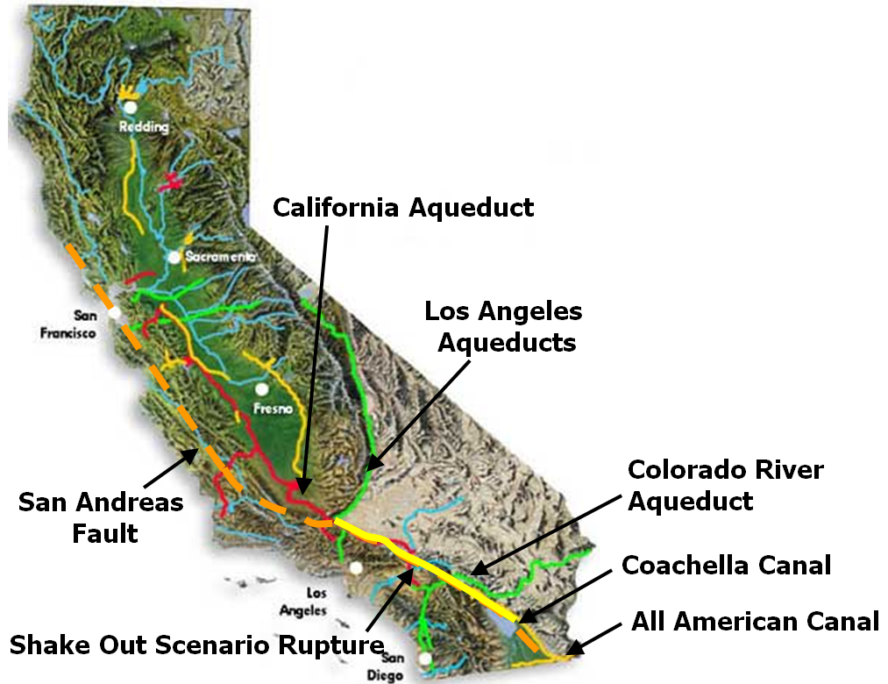
Southern California highly dependent on imported water
Population: 22 Million
East Branch Most Vulnerable

Protecting Water Supplies (Courtesy of Prof. Tom O’Rourke, Cornell University- Closing Presentation at the NHERI Science Plan Workshop, March 19-2019, Alexandria Virginia- [LINK])

There are more than 7,000 km of cast-iron main water pipes in Los Angeles. Their level of performance and vulnerability against a natural hazard event is unknown, but their performance in strong ground-shaking from earthquakes is thought to be poor. What is needed is to develop the science and engineering tools to identify the weaknesses in the system, to replace or upgrade the components so the network can perform at the level expected, and to develop strategies to ensure that the system is resilient and recovers quickly after damage or failure.

The problems that all lifeline networks have are similar. Thus, lessons learned and solutions proposed for one of the networks, e.g. water, can be used for others such as power, gas and waste systems. There are also interdependencies between lifelines —such as the delivery of water which is often dependent on the availability of power —which also must be understood. The research will address the following key questions:

(1) What are the complex interactions between lifelines and how should we define these interactions among systems and within the community; (2) how should we assess the current performance of the elements of the system; (3) how should we assess network reliability and perform network analysis such that the weak elements of the system are identified; (4) what are the best and optimum strategies to replace or repair elements in the system; (5) what is the best strategy for recovery once the system is damaged; and (6) what are the short-term and long-term environmental impacts of any retrofit, upgrade or replacement.

Intellectual Merit:
The research proposed will contribute to the resilience of lifelines systems and make the infrastructure of the nation more resilient against natural hazards. More specifically, the proposed research will: (1) provide new knowledge and tools for network analysis and damage estimation; (2) determine the interplay between lifelines and buildings and between humans and systems; (3) quantify the interaction between ground response and lifelines; and (4) create new scalable models to simulate the response of the systems both at the element level and at the network level.

The following disruptive technologies have high potential to advance the research: new methods and new materials for ground improvement; robotics to evaluate and repair elements of the network; additive manufacturing for repair and retrofit; sensors and sensing for real-time monitoring of the network performance; big data and artificial intelligence for asset management; 3D imaging to characterize the subsurface; real time hybrid simulation and high-fidelity network analysis to model the network.

Broader Impacts:
The loss of lifelines, e.g. water, power, etc. disrupts gravely the communities affected, as has been the case in Puerto Rico, after Hurricane Maria, and as observed by the power loss in Venezuela. Disruption, economical and personal losses, affect disproportionally minorities and populations in the lower economic strata of society. Improvements on the resilience of lifelines will have a very large and positive impact across all members of society, especially those less-favored economically. The results of the research can influence policy and/or be used by policymakers to prioritize operations and to choose the best financial mechanisms.

The research is highly interdisciplinary, as it needs to bring together expertise from different communities, that in a very broad sense, include: (1) Imaging, to characterize the system and its spatial variability; (2) Decision-support analysis, to develop new strategies for replacement, improvement or retrofit; (3) Social sciences, to involve the community in the decision-making process; and (4) Communication, to bring the research findings to all stakeholders.

Examples of Research Campaigns for Windstorms

Example 1: Immediate Occupancy of Low-Rise Buildings Following Windstorms

Research Challenge:
Enable immediate occupancy of low-rise buildings (including residential, commercial, and critical facilities such as schools and hospitals) impacted by hurricane winds and rain. This campaign includes future and existing buildings located in coastal as well as inland communities.

The campaign will address economic and cultural viability of solutions, recognizing the incredible socio-economic diversity of affected communities.

Storm surge, Hurricane Fran, North Carolina 1996

Intellectual Merit:
The goal is to develop the knowledge-base and tools needed to allow viable retrofits of existing buildings, and design and construction of new buildings, including the following competencies:
- Identify uncertainties in wind and wind-driven rain loading, and system resistance to determine where to focus research.
- Advance research that enables design and installation of ventilation, door and window systems that prevent water entry.
- Develop interdisciplinary engineering field diagnostic tools to assess existing building vulnerabilities while also including social science instruments that capture the socio-demographic characteristics of occupants.
- Refine the understanding of wind-borne debris (e.g., extent of the wind-borne debris region, design momentum, rain resistance after debris impact, applicability to elements in addition to glazing).
- Develop design strategies to reduce localized wind loads.
- Further develop computational fluid dynamics (CFD) with the aim of using it to develop wind loads, and augment assessment of building envelope resistance (currently determined by testing).
- Develop behavioral nudge strategy to facilitate implementation of individual and community-wide resilience through mitigation.
- Carefully consider economic barriers to adoption of particular mitigation strategies at the individual household as well as community level. Develop a range of policy options to address economic and social inequalities that may delay adoption.

Broader Impacts:
With significant projected population increases in hurricane-prone regions in the next few decades, and the potential ramifications of climate change, a notable improvement in the number of buildings in a community that can be immediately occupied after a hurricane will have a profound impact on the health and overall quality of life for millions of U.S. residents.

Although there have been significant improvements in design and construction of low-rise buildings since Hurricane Andrew devastated Florida in 1992, recent hurricanes have caused billions of dollars in damages to communities and widespread disruption and dislocation because relatively few buildings have been suitable for immediate occupancy. Prolonged building disruption presents significant economic, social, and mental health challenges to inhabitants of communities and negatively impacts a community’s ability to rapidly recover. Clearly, a fundamental change to the current situation is needed to lessen the impact of more frequent and large-scale disasters on communities.

Research Campaign Strategy:
- Submit a planning grant.
- Use the Science of Team Science to identify team members, which could include representatives from, for example, public policy, sociology, demography, economics, engineering, architecture, building science, and construction management. Given the present and growing diversity of the coastal and inland areas, every effort will be made to include scholars from Historically Black Colleges and Universities (HBCU’s) and Hispanic Serving Institutions. In addition, to ensure broader applications, the team will also invite private sector representatives who can assist with future workforce training opportunities.
- Explore disruptive technologies that can be utilized in the research campaign.
- Use the following NHERI facilities: CONVERGE, FIU Wall of Wind, RAPID, SimCenter, and U of Florida Wind Facility.
- Timeline: Some research results will move into practice in the near-term (5 to 10 years). Other research results will be long-term (greater than 10 years).

Example 2: Mega-disasters
Research Challenge: We want to shift the focus from chronic storms (hurricanes/tornadoes) to very acute thinking in terms of mega-disasters (e.g., atmospheric rivers), which involve a multi-state shock and are highly unpredictable by nature, taking lifeline systems offline and completely collapsing state governments. In order for the country to be resilient to such a mega-disaster, this research campaign proposes to establish programs, build trans-disciplinary, inter-agency, and international collaborations, and perform fundamental research in operational settings, using all existing NHERI facilities, as well as potentially extending or developing additional facilities specific to the hazard characteristics. The immediate focus of the proposed research campaign will result in a five-year timeline, with a need to re-assess at the end of the five years. The programs developed will initially focus on: (1) characterization of the hazard and loads; (2) prioritization of infrastructure or improved structural performance; and (3) creating an idealized recovery plan for execution in the event of the mega-disaster. A goal of the research campaign is to enable communities to be better prepared for extreme hazard events, as well as to generate the knowledge to build back in a more sustainable, efficient, and resilient manner, at 20% of the current social and economic cost.

Intellectual Merit:
The success of this research campaign will result in an efficient recovery plan that utilizes disruptive technologies, such as artificial intelligence, robotics, bio-inspired design, additive manufacturing, and advanced materials. The recovery plan will rely on hyper-redundancies to provide efficient and effective response after the disaster event. New science will be generated on: (1) rapidly deployable, pre-fabricated sheltering and rebuilding strategies; (2) artificially intelligent-optimization of building designs and standards; (3) high through-put experimental (design-build-test) research.

Broader Impacts:
This research campaign will organize workshops with individuals from different disciplines, utilizing science-of-team-science strategies to sustain a convergence program on mega-disasters. The research campaign will integrate fundamental research into operation through inter-agency coordination (e.g., NASA, DOE, DOD, etc.) and will engage the public such that responsibility is shared across all community members from the local to federal level. To address this challenge, a diverse team with representation from under-represented groups will be necessary. The campaign will also focus on educating the public, not only on the detrimental effects of such a disaster, but also on the response and recovery processes which will be executed in the event of such a disaster, where in this type of event, key researchers and public officials may not be available to carry out proper procedures.

Examples of Research Campaigns for Storm Surge and Tsunami in Coastal Areas

Example 1: Community-Level Management of Storm Surge and Tsunami Hazards

Research Challenge:
We envision a research campaign to develop the scientific and engineering knowledge needed to create the next generation of decision-support technologies for systems-of-systems-based, community-level management of vulnerabilities associated with storm surge and tsunami hazards. The goal is to generate actionable knowledge and tools to inform values-based coastal planning over a 30-50-year time horizon and to incorporate long-term adaptation and risk management into the disaster recovery phase. Through computational modeling, and laboratory and field experiments, we will explore how the engineered design of sociotechnical systems should change in response to different planning regimes focused on maintaining the resilience and sustainability of coastal communities.

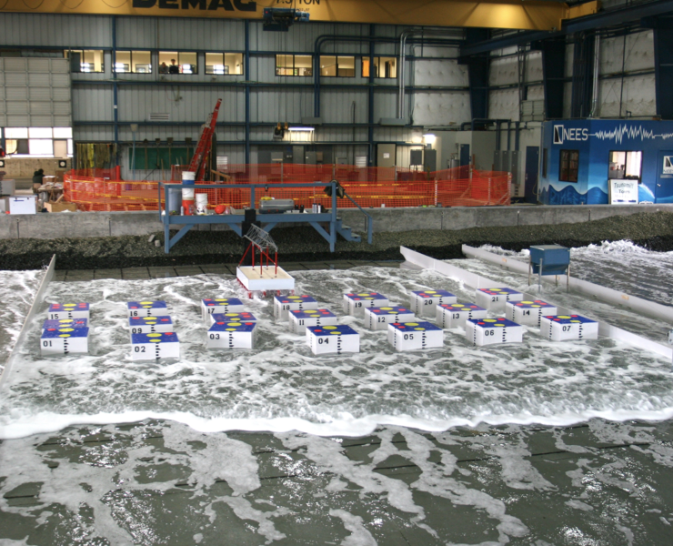
Directional Wave Basin (3D) at the NHERI@OSU Facility (courtesy of Dan Cox, NHERI@OSU Principal Investigator)

Projects would include coordinated efforts between multiple NHERI facilities spanning wave and wind experimental facilities, along with the SimCenter and RAPID. Another key element of this campaign is transdisciplinary engagement with local decision-makers and stakeholders in a diverse set of city/community-level test beds. Experiments might include a mix of individual and integrated studies of elements at multiple scales (e.g., materials, components, buildings, public infrastructure). In addition, studies still need to quantify uncertainty associated with engineering performance of natural and nature-based features. Regardless of scale, they should be motivated by how findings would enable better decision-making using contemporary approaches for decision-making under deep uncertainty (e.g., dynamic adaptive policy pathways, multi-objective robust decision-making). Examples of these contributions include development of decision-relevant, community-level metrics; uncertainty quantification; and joint probability analysis of surge and wind hazards.

Intellectual Merit:
Research projects are encouraged to incorporate disruptive and emerging technologies. This may include innovative sensors, virtual or augmented reality, robotic contributions to post-storm coastal remediation, agent-based modeling of risk-induced emergent behaviors, and bio-inspired improvement of soil geotechnical characteristics. Integration of lab and numerical experiments with test bed communities creates opportunities for transdisciplinary coproduction of knowledge by researchers (e.g., engineering, social sciences, physical sciences) and decision-makers, planners and residents. In addition, the knowledge generated will expand current approaches to simulate storm impacts on communities to account for the combined effect of rainfall, groundwater flow, drawdown, wind and surge.

Broader Impacts:
Selection of demographically and socioeconomically diverse testbeds will include traditionally underrepresented communities in the hazard mitigation process, reduce social vulnerability, and promote community engagement in planning processes. Incorporating local knowledge into projects at the proposal and development stage will lead to greater likelihood of successful technology transfer and policy implementation utilizing the campaign’s research products.

Example 2: Comprehensive numerical simulation platform for hurricanes and tsunamis: from source to impact

Research Challenge:
This research campaign envisions a multi-year (5-10 years) research program consisting of multiple collaborative proposals that include the use of disruptive technologies. It will lead to the development of a comprehensive numerical simulation platform for modeling hurricanes and tsunamis from source to impact on coastal communities. The numerical platform will be a multi-scale, multi-phase simulation that includes interaction with the natural environment, built environment and population. The comprehensive simulation platform will include the effects of wind, storm surge, surface waves, tsunami surge and bores, sediment transport, scour, and debris entrainment, damming and impact. Simulations will initiate either from the cyclone development or tsunami source and propagate at large-scale towards the coastline. Incrementally smaller scales will be employed to model the effects of near-shore bathymetric features, coastal topography and the built environment, which will be modeled in detail with appropriate fragility functions to simulate failure of weaker structures that contribute to entrained debris. Population distribution and demographics will be included in an agent-based model to simulate evacuation of the affected population either to high-ground or to vertical evacuation refuges.

A multi-disciplinary team including oceanographers, meteorologists, coastal, structural and geotechnical engineers, computer scientists, computational mechanics, social scientists, community representatives and policy makers, will develop the computational platform. It will function either as a single mega-simulation tool including all components of the model, or as a suite of inter-operational simulation tools. Development and validation of the platform will be supported by laboratory experimentation, field reconnaissance observations and social science research. Simulation output will include time-histories of flow parameters at critical locations, hydrodynamic and debris impact loading on structures, sediment transport and scour, effectiveness of the community evacuation strategy, and casualty and loss estimation.

Once developed, the platform will be available for generating probabilistically-based scenarios for non-emergency application to community planning, infrastructure design, loss estimation and impact modeling. Machine learning will be used to develop predefined scenarios for evacuation support during future events using real-time input from the affected population and field sensors. The platform will be open source, portable and adaptive to future computational developments.

Intellectual Merit:
Developing this multi-scale, multi-phase, multi-disciplinary, multi-hazard comprehensive computational platform will require development of advanced high-performance computational tools. The platform will be validated using reconnaissance observations, casualty and loss estimates from past events. Innovative laboratory experiments will be performed in the NHERI tsunami wave basin (OSU) and wind facilities (UF and FIU) in collaboration with the Simulation Center, DesignSafe and Converge. The experiments will utilize 3D printing to generate scale models of realistic natural and infrastructure components using materials with appropriate strength, stiffness and ductility. Test-bed communities with differing socio-economic, geo-political and population distributions will be modeled to verify the platform application to a wide range of realistic coastal communities.

Broader Impacts:
This campaign will provide a comprehensive simulation tool that will aid risk-informed decision making for coastal communities. The platform will enable evaluation of evacuation plans, community planning decisions, mitigation efforts, and associated benefit-cost analyses. Implementation of this platform will lead to more resilient coastal communities with the associated reduction in casualties and financial consequences of future hurricanes and tsunamis.

Summary and Next Steps

A workshop on March 18-19, 2019, was held in Alexandria VA to advance the NHERI Five Year Science Plan. There were more than 70 participants representing the U.S., Japan, Italy, England, and Korea. The workshop had two main objectives: (a) Identify the contributions from disruptive/transformational technologies to the NHERI Science Plan to achieve the vision of NHERI; and (b) Elucidate potential research campaigns encompassing one or all of the hazards under the scope of NHERI. The workshop brought together researchers in areas of transformational technologies including bio-inspired design, advanced computation, data science, materials science, additive manufacturing, robotics and control theory as well as social and behavioral sciences. Participants also explored the science of team science, a new interdisciplinary field that empirically examines the processes by which large and small scientific teams, research centers, and institutes organize, communicate, and conduct research.

The workshop environment served as a catalyst for transformative thinking by the participants on research campaigns focused on reducing the impact of earthquakes, windstorms, and associated events such as tsunami and storm surge in coastal areas. The research campaign examples fell under the following themes:

  - Earthquakes and Related Landslides: Resilience of Lifeline Systems;
  - Windstorms: Example 1 - Immediate Occupancy of Low-Rise Buildings Following Windstorms and Example 2- Mega-disasters;
  - Storm Surge and Tsunami in Coastal Areas: Example 1- Community-Level Management of Storm Surge and Tsunami Hazards, and Example 2: Comprehensive Numerical Simulation Platform for Hurricanes and Tsunamis: from Source to Impact.
These examples and the input received during the workshop will be taken by the Science Plan Task Group under the leadership of the Network Coordination Office (NCO) and the input from the NHERI components to develop the next edition of the NHERI Science Plan and submit to NSF and share with the community on July 2019 via DesignSafe-CI for comment. Shortly after the public comment period, the Task Group will respond to public comments and reflect the input in the Science Plan as needed.

The plan will then be extensively disseminated via the NHERI cyberinfrastructure, to researchers and practitioners in the natural hazards community and to the National Science Foundation for possible use in Dear Colleague Letters and workshops, at professional meetings and with our partners in the U.S. and abroad. The outcome of the Science Plan will lead to a safer environment, reduction in property damages and loss of life in communities affected by natural hazards from earthquakes, windstorms and coastal storms and tsunamis.

APPENDIX 1

Workshop Agenda

Westin-Alexandria, VA

Day 1, 18 March 2019

7:30 | Registration – Dan Zehner and Cheryl Ann Blain -- Edison Ballroom
8:00 – 9:30 Plenary Session I: Moderator: Joy Pauschke, Program Director, ENH and NHERI, National Science Foundation – Edison Ballroom
 | Welcome and Opening Remarks – Joy Pauschke
Objectives of the Meeting
Julio Ramirez, Karl H. Kettelhut Professor in Civil Engineering and NHERI-NCO Center Director, and Billy L. Edge, P.E., Dist.M. ASCE, North Carolina State University

Summary of NHERI 5-Year Science Plan and Social Science View
Lori Peek, Professor, Department of Sociology, Director, Natural Hazards Center, University of Colorado Boulder
 | Expanding the Vision of Science and Engineering for the Natural Hazards Community, Timothy M. Persons, SES, Chief Scientist of the United States Government Accountability Office (GAO)
9:30 | Break (coffee and refreshments)
9:45 – 10:45 Plenary Session II: Panel – A vision for future hazard mitigation/disruptive technologies not addressed in the NHERI Science Plan- Edison Ballroom
Moderator: Bill Holmes, Rutherford + Chekene

- Data-driven disaster science: an artificially intelligent approach to performance-based engineering, Stephanie Paal, Assistant Professor, Texas A&M University
- Bio-mediated Geotechnical Technologies for Natural Hazards Engineering, Mike Gomez, Assistant Professor, University of Washington
- Coastal mitigation parks against tsunamis: how effective are they? Simone Marras, Assistant Professor, New Jersey Institute of Technology
- Convergence Research for Integrating Societal Dimensions into Engineering and Planning of Resilient Infrastructure Systems, Ali Mostafavi, Assistant Professor, Texas A&M University
- Incentivizing community-level disaster preparedness by amending to the Stafford Act, Allison Reilly, Assistant Professor, University of Maryland
- Biomimetic Resilience: What Can We Learn from Nature? Will Srubar, Assistant Professor, University of Colorado Boulder
10:45 – 12:15 Plenary Session III: Keynote Talks - Edison Ballroom
Moderator: Forrest Masters, University of Florida
 | Leveraging NSF ERC Funding with NHERI Facilities, Edward Kavazanjian, Jr., Regents’ Professor and Director of Center for Bio-mediated and Bio-inspired Geotechnics, Arizona State University
 | Science of Team Science - Best Practices and Future Directions for Interdisciplinary Teams, Edward T. Palazzolo, Army Research Office, Program Manager for Social and Cognitive Networks
 | Patience and Stewardship over Generations: LIGO's Detector Facilities and Recent Discoveries, Joseph A. Giaime, Professor of Physics & Astronomy (LSU), Observatory Head, LIGO Livingston, Caltech
12:15 | Lunch (on your own)
13:00 – 13:40 Introduction to Three Breakout Sessions – I (Part A) Edison Ballroom
Moderator: Jerome Lynch, University of Michigan
- Advanced Computational Methods and High-Performance and Real-Time Computing, Leader: Chris Gill, DSc, Washington University, St. Louis, Recorder: Liliana Velasquez Montoya, North Carolina State University
- Data-Driven Science, Leaders: Maria Dillard, NIST, Lori Peek, University of Colorado Boulder, Elaina Sutley, University of Kansas, Recorder: Haorui Wu, University of Colorado at Boulder
- Robotics - Mobile Manipulation in Uncertain Environments, Leader: Kyle D. Edelberg, NASA’s Jet Propulsion Lab, Recorder: Navid Jafari, Louisiana State University
13:40 | Transition to Breakout Sessions
13:45 – 14:45 Advanced Discussion on Three Breakout Sessions – I (Part A)
- Advanced Computational Methods and High-Performance and Real-Time Computing – Banneker Room
- Data-Driven Science – Edison Ballroom
- Robotics - Mobile Manipulation in Uncertain Environments – Bell Room
14:45 | Break (coffee and refreshments)

15:00 – 15:40 Introduction to Three Breakout Sessions – I (Part B) Edison Ballroom
Moderator: Chris Gill, Washington University
- Bio-Inspired Design, Leader: Jerry Lynch, University of Michigan, Recorder: Simone Marras, New Jersey Institute of Technology
- Additive Manufacturing, Leader: Zhijian Pei, Texas A&M University, Recorder: Maria Koliou, Texas A&M University
- Advanced Materials, Leader: Pablo Zavattieri, Purdue University, Recorder: Michael Gomez, University of Washington
15:40 | Transition to Breakout Sessions
15:45 – 16:45 Advanced Discussion on Three Breakout Sessions – I (Part B)
- Bio-Inspired Design– Banneker Room
- Additive Manufacturing – Edison Ballroom
- Advanced Materials – Bell Room
16:45 | Break
17:00  17:30 | Expectation and organization of Day 2 – Edison Ballroom  Moderator: Julio Ramirez, Purdue University  Adjourn

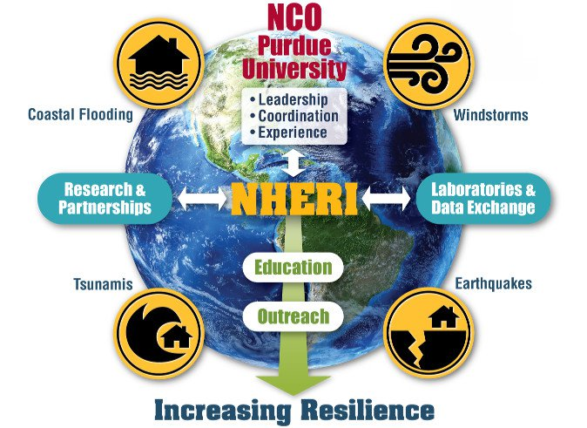

Day 2

19 March 2019

8:00 | Breakout Sessions – II – Examples of Research Campaigns: Operation of research campaign – team selection & coordination, implementation, and best practices  Example 1: Earthquake and Related Landslides – Scope, Using NHERI Facilities, Community Engagement, Metrics for Success – Edison Ballroom  Moderators: Bill Holmes, Rutherford + Chekene; Edward Kavazanjian, Arizona State University; and Michele Calvi, University of Pavia  Recorder: Antonio Bobet, Purdue University  Example 2: Windstorm Hazards– Scope, Using NHERI Facilities, Community Engagement, Metrics for Success –Banneker Room  Moderators: Thomas L Smith, TL Smith Consulting; Forrest Masters, University of Florida; and Greg Kopp, University of Western Ontario  Recorder: Stephanie Paal, Texas A&M University  Example 3: Storm Surge and Tsunami Hazards in Coastal Areas– Scope, Using NHERI Facilities, Community Engagement, Metrics for Success – Bell Room  Moderators: Ian Robertson, University of Hawaii at Manoa; Dan Cox, Oregon State University; and Tiziana Rossetto, University College London  Recorder: Liliana Velasquez Montoya, North Carolina State University  (Examples will be defined by the Workshop Organizing Committee and distributed before this session. A member of the Committee will facilitate each session.)
10:15 | Break (coffee and refreshments)
10:30 | Report Results of Breakout Sessions – II – Edison Ballroom  Moderator: Billy Edge, North Carolina State University, Moderator
11:15 | Closing Session: Frontiers of Hazard Risk Mitigation, Thomas Denis O’Rourke, PE, NAE, Thomas R. Briggs Professor of Engineering in the School of Civil and Environmental Engineering, Cornell University – Edison Ballroom
12:15 | Adjourn

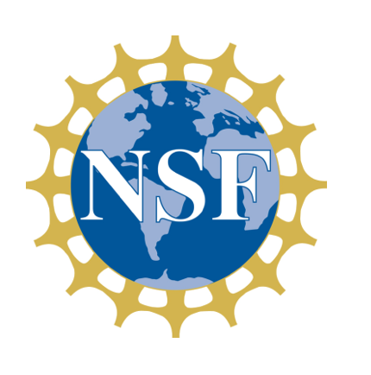
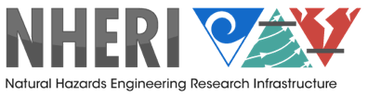

APPENDIX 2

Workshop Participants
William Allsop | william.allsop51@outlook.com | William Allsop Consulting Ltd.
Cheryl Ann Blain, Ph.D. | cheryl.ann.blain@nrlssc.navy.mil | NHERI-NCO, NRL, Oceanography Division
Antonio Bobet, Sc.D. | bobet@purdue.edu | NHERI-NCO, WOC, Purdue University
Gian Michele Calvi, Ph.D. | gm.calvi@unipv.it | EUCENTRE Foundation, Pavia, IT
Liang Cao, Ph.D. | lic418@lehigh.edu | NHERI EF, Lehigh University
Patricia Clayton, Ph.D. | clayton@utexas.edu | NHERI EF, UT Austin
Dan Cox, Ph.D. | dan.cox@oregonstate.edu | NHERI EF, OSU
Greg Deierlein, Ph.D. | ggd@stanford.edu | NHERI SimCenter, Stanford U.
Maria Dillard, PhD | maria.dillard@nist.gov | Community Resilience Group, NIST
Robin Dillon-Merrill | rdillonm@nsf.gov | National Science Foundation
Shirley Dyke, Ph.D. | sdyke@purdue.edu | MECHS, Purdue University
Kyle Edelberg, Ph.D. | Kyle.D.Edelberg@jpl.nasa.gov | Jet Propulsion Lab, NOAA
Billy L. Edge, P.E., Ph.D., Dist. M. ASCE | bedge@civil.tamu.edu | NHERI-NCO, WOC, North Carolina State University
Edward T. Edward T. Palazzolo, Ph.D. | edward.t.palazzolo.civ@mail.mil | WOC, Army Research Office on Social and Cognitive Networks
Lesley E Ewing, Ph.D. | Lesley.Ewing@coastal.ca.gov | NHERI, NIAC
Forrest Masters, Ph.D. | masters@ce.ufl.edu | NHERI EF, WOC, University of Florida
Richard Fragaszy, ECI, rfragasz@nsf.gov | rfragasz@nsf.gov | National Science Foundation
Gerry Galloway, Ph.D. | gegallo@umd.edu | University of Maryland
Joseph A. Giaime, Ph.D. | jgiaim1@lsu.edu | Observatory Head, LIGO Livingston, Caltech
Christopher Gill, Sc.D. | cdgill@wustl.edu | WOC, Washington University in St. Louis
Mike Gomez, Ph.D. | mggomez@uw.edu | University of Washington
Bill Hansmire | William.Hansmire@wsp.com | NHERI, NIAC
William T. Holmes, S.E., N.A.E. | WHolmes@ruthchek.com | NHERI-NCO, WOC, Rutherford + Chekene Consulting Engineers
Navid Jafari, Ph.D. | njafari@lsu.edu | Louisiana State University
David Johnson, Ph.D. | davidjohnson@purdue.edu | NHERI-NCO, Purdue University
Tori Johnson, Ph.D. | vjohnson@usna.edu | United States Naval Academy
Ahsan Kareem, Ph.D. | Ahsan.Kareem.1@nd.edu | NHERI SimCenter, Notre Dame University
Edward Kavazanjian, Jr., Ph.D., PE, GE, D.GE, Dist.M.ASCE, NAE | Edward.Kavazanjian@asu.edu | Arizona State University
Chul-Young Kim, Professor, Ph.D. | cykim@mju.ac.kr | Myongji University, South Korea
Maria Koliou, Ph.D. | maria.koliou@tamu.edu | Texas A&M University
Gregory A. Kopp, Ph.D., PEng | gakopp@uwo.ca | University of Western Ontario, CAN
Masahiro Kurata, Professor, Ph.D. | kurata.masahiro.5c@kyoto-u.ac.jp | DPRI, Kyoto University, Japan
Marc Levitan | Marc Levitan marc.levitan@nist.gov | NIST
Jerome P. Lynch, Ph.D. | jerlynch@umich.edu | WOC, University of Michigan
Claudia C. Marin, Ph.D. | cmarin@howard.edu | Howard University
Simone Marras, Ph.D. | simone.marras@njit.edu | New Jersey Institute of Technology
Farnyuh Menq, Ph.D. | fymenq@utexas.edu | NHERI EF, UT Austin
Judy Mitrani-Reiser, Ph.D. | judith.mitrani-reiser@nist.gov | NIST
Gilberto Mosqueda, Ph.D. | gmosqueda@eng.ucsd.edu | NHERI EF, UC San Diego
Ali Mostafavi, Ph.D. | amostafavi@civil.tamu.edu | Texas A&M University
Pallab Mozumder, Ph.D. | mozumder@fiu.edu | Florida International University
Thomas Denis O’Rourke, Ph.D., NAE | tdo1@cornell.edu | Cornell University
Ozgur Ozcelik, Ph.D. | oozcelik@eng.ucsd.edu | NHERI EF, UC San Diego
Stephanie Paal, Ph.D., | spaal@civil.tamu.edu | WOC, Texas A&M University
Joy M. Pauschke, Ph.D. | jpauschk@nsf.gov | National Science Foundation
Lori Peek, Ph.D. | Lori.Peek@colorado.edu | NHERI CONVERGE, WOC, University of Colorado Boulder
Zhijian (ZJ) Pei, Ph.D. | zjpei@tamu.edu | WOC, Texas A&M University
Timothy Persons, PhD, SES | personsT@gao.gov | Chief Scientist, Government Accountability Office
Julio A. Ramirez, Ph.D. | ramirez@purdue.edu | NHERI-NCO , WOC, Purdue University
Ellen M Rathje, Ph.D. | e.rathje@mail.utexas.edu | NHERI DesignSafe, UT Austin
Dorothy A. Reed, Ph.D., P.E. | reed@u.washington.edu | University of Washington
Allison Reilly, PhD | areilly2@umd.edu | University of Maryland
Ian Robertson, P.E., Ph.D. | ianrob@hawaii.edu | NHERI-NCO, WOC, University of Hawai’i at Manoa
Tiziana Rossetto, Ph.D. | t.rossetto@ucl.ac.uk | University College London, GB
Stephanie Smallegan, Ph.D. | ssmallegan@southalabama.edu | University of South Alabama
Thomas L. Smith, AIA, RRC, F.SEI | tlsmith@hughes.net | NHERI-NCO, WOC, TLSmith Consulting Inc
Solomon C. Yim, Ph.D., P.E. | solomon.yim@oregonstate.edu | Oregon State University
Will Srubar, Ph.D. | wsrubar@colorado.edu | University of Colorado Boulder
Max Stephens | max.stephens@pitt.edu | NHERI, User Forum
Elaina J. Sutley, Ph.D., | enjsutley@ku.edu | University of Kansas
Georgios Tsionis, Professor, Ph.D. | georgios.tsionis@ec.europa.eu | JRC, SERA Project, Ispra, IT
Liliana Velasquez Montoya, Ph.D. | lvelasq@ncsu.edu | North Carolina State University
Peter Vickery, Ph.D. | pvickery@ara.com | NHERI NIAC
Ty Wamsley, Ph.D. | wamslet@wes.army.mil | USACE
Yumei Wang, Ph.D. | Yumei.WANG@oregon.gov | Oregon Dept. of Geology and Mineral Industries
Joe Wartman, Ph.D. | wartman@uw.edu | NHERI RAPID EF, University of Washington
Meagan Wengrove, Ph.D. | meagan.wengrove@oregonstate.edu | Oregon State University
Dick Woods, Ph.D. | rdw@umich.edu | NHERI NIAC
Haorui Wu | Haorui.Wu@Colorado.EDU | University of Colorado at Boulder
Pablo Zavattieri, Ph.D. | zavattie@purdue.edu | Purdue University
Dan Zehner | zehner2@purdue.edu | NHERI-NCO, Purdue University
Katerina Ziotopoulou Professor, Ph.D. | kziotopoulou@ucdavis.edu | NHERI EF, UC Davis
Ioannis Zisis, Ph.D. | izisis@fiu.edu | NHERI EF, FIU
Delong Zuo, Ph.D. | delong.zuo@ttu.edu | NHERI-NCO, Texas Tech University

APPENDIX 3

Session Details

Dr. Joy Pauschke, National Science Foundation (NSF) Program Director for ENH and NHERI, opened the workshop and welcomed the participants. She discussed the NSF motivation to establish NHERI and funding opportunities for its users.

Social Science Perspective of the NHERI Science Plan

During the first plenary session of the workshop, Prof. Lori Peek, Director, Natural Hazards Center of the University of Colorado Boulder and Principal Investigator, NSF-NHERI CONVERGE, elaborated on the social view of the NHERI Science Plan (Summary of NHERI 5-Year Science Plan and Social Science View, [LINK]). In her presentation, Dr. Peek noted that 2017 was an unprecedented year in the wake of Hurricanes Harvey, Irma, Maria, and the California wildfires, with more than 25 million people affected by these major disasters — almost 8 percent of the United States population (FEMA, 2018).

Climate change and socio-economic factors have contributed to this trend such as the population growth in the U.S. (Figure 1) and the concentration of the population in areas of considerable exposure to natural hazards, growing income inequality, and insufficient coordination between land use policies and information on exposure to natural hazards. Dr. Peek further delved into the question of how to advance the vision of the plan for achieving more resilient communities by preventing natural events from becoming social catastrophes. She specifically challenged the audience to be forward thinking futurists and to work in diverse teams to seek convergence for science and solutions.

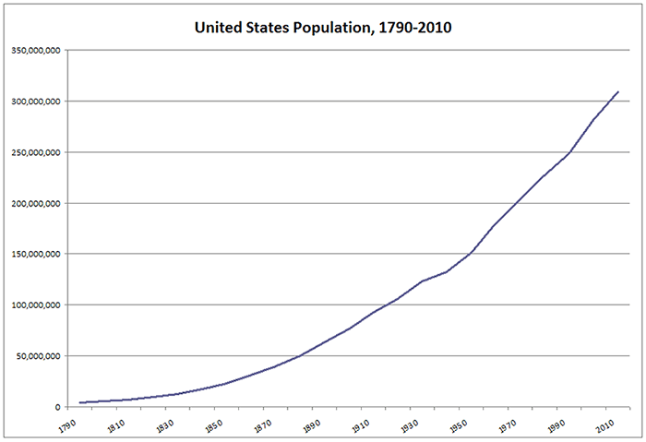
United States Population Growth

Expanding the Vision of Science and Engineering for the Natural Hazards Community

In the keynote talk of the opening plenary session, Dr. Timothy M. Persons, Chief Scientist of the United States Government Accountability Office (GAO), addressed the participants (Expanding the Vision of Science and Engineering for the Natural Hazards Community, [LINK]) and provided mileposts to guide their efforts to expand the vision of the Science Plan by incorporating disruptive technologies. Dr. Persons elaborated:

- “Data are the new oil” – Tremendous opportunities exist for this community to embrace key trends and shape them toward positive ends.
- Innovation “sandboxes” will be needed to identify issues and test the technologies in a realistic environment to determine the extent to which they enhance quality, timeliness, and ultimately, relevance.
- The successful way forward is symbiotic – improved/empowered human decision frameworks augmented by machines.
- Vocations will be required to adapt to the probabilistic (vs. deterministic) paradigm.
- The greatest challenges ahead are socio-cultural, not technical. (“Culture eats strategy for breakfast.”)

Science of Team Science: Best Practices and Future Directions for Interdisciplinary Teams

Edward T. Palazzolo, Army Research Office, Program Manager for Social and Cognitive Networks, spoke on the topic of team science. The vision for social and cognitive networks (SCN) is an ability to predict emergent phenomena in teams, organizations, and populations by creating new measures, models, and theories that capture cognitive and behavioral processes of networked human systems to provide administrators and team members with tools and techniques to explore their decision option space for improved decision-making. Achieving this vision requires a combination of team science, computational social science and social network analytics.

An important component of SCN is Transactive Memory Theory (TM), which explains how a person makes use of the knowledge of others. It examines how team members obtain, organize and access new knowledge. TM can provide a framework for understanding how people share knowledge for task completion through communication.

Dr. Palazzolo showed that collective intelligence can be measured like an IQ test to determine the general cognitive ability of teams. Collective intelligence is capable of measuring “social perceptiveness” of team members and creating standardized instrumentation for face-to-face and online teams and equality of distribution of turn-taking during discussions. Collective intelligence is used to predict team performance and success. It can predict team learning ability, success on future team tasks and long-term successes. The impact on team science should allow:
- The ability to design more effective teams;
- training opportunities for broad participation in decision-making to create more intelligent teams;
- the development of targeted communication skills for improved performance in face-to-face and online teams.

Professor Hanghang Tong at Arizona State University recently studied new algorithms and tools for predicting team performance. He found that there is no known specific process for building high performance teams. However, his concepts, shown in Figure 2, suggest that the process to develop highly productive teams would:
- Develop algorithms for team-member replacement;
- design a platform to search and identify team member replacements;
- develop algorithms to jointly predict individual productivity and team performance; and
- conduct experiments to test systems.
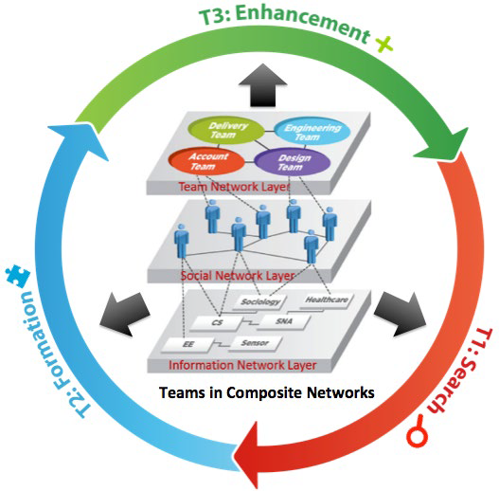
Design of High-Performance Teams (Source: Hanghang Tong)

Following the key metrics and procedures that produce maximum team performance into team selection and refinement over time, the project leadership can improve the team resource, make better decisions to perform tasks needing collaborative effort from the team and provide feedback to individuals to generate more productive behavior.

Leveraging NSF ERC Funding with NHERI Facilities

Edward Kavazanjian, Jr., Regents’ Professor and Director of Center for Bio-mediated and Bio-inspired Geotechnics at Arizona State University spoke on the topic of NSF’s Engineering Research Centers. ERCS are interdisciplinary, multi-institutional centers that form partnerships between academia, industry and governmental agencies to create transformational engineered systems. Currently there are a total of 20 ERCs in the U.S., one of which is the Center for Bio-mediated and Bio-inspired Geotechnics (CBBG). The center is focused on nature-inspired geotechnical solutions for civil infrastructure with four thrust areas:
- Hazard Mitigation
- Environmental Protection
- Infrastructure Construction
- Subsurface Exploration and Excavation

Of significant importance is an emerging sub-discipline in geotechnical engineering that include bio-mediated processes that are managed and controlled through living biological activity. It also includes bio-inspired processes with biological principles employed to develop new abiotic solutions with no living organisms. Sustainable and resilient geotechnical systems can be built mimicking nature, which has developed many elegant and efficient biogeotechnical processes over eons. The figure below is a familiar success from nature as the foundation of the mangrove tree has adapted a sustainable anchoring system.
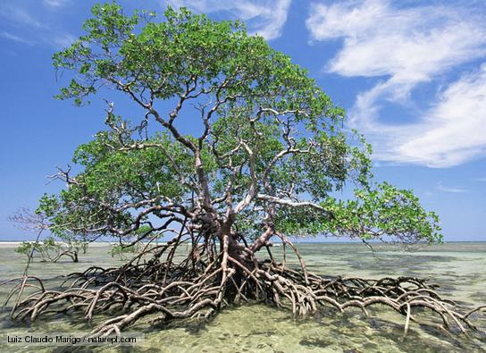
Learning from Nature: Stability with Resilient Foundations

The slow geologic time scales of carbonate precipitation processes yielding carbonate sediments, cemented sand and stalactites are well known. However, there are carbonate precipitation processes that occur on an engineering time scale such as mollusk shells, fouling of well screens, and clogging of water treatment plant filters. The question is whether anthropogenic processes can be induced in a context where the effect is beneficial. Potentially successful applications can lead to increased bearing capacity, better slope stability, erosion control and improvement in underground construction.

Calcium carbonate precipitation can occur via one of these three biogeotechnologies:
- Microbially Induced Carbonate Precipitation (MICP) via ureolysis
- Microbially Induced Desaturation and carbonate Precipitation (MIDP) via denitrification
- Enzyme Induced Carbonate Precipitation (EICP) via ureolysis

A Vision for Future Hazard Mitigation/Disruptive Technologies Not Addressed in the NHERI Science Plan

To strengthen the futuristic view of hazard risk mitigation, early career professionals were invited to participate in the workshop. To maximize interest and opportunities for young professionals to attend and contribute to the workshop, a Call for Idea Presentations was established. The Workshop Organizing Committee submitted the call to many engineering and science programs including collegiate and practicing professionals. They were asked to prepare an essay on their vision for the future of hazard mitigation/disruptive technologies. The Organizing Committee carefully reviewed all submissions. Special attention was made to invite participants that would create a diverse group. The final selection included a balanced group of early career faculty including factors such as disciplinary expertise, gender, race and ethnicity. The Organizing Committee sought both NHERI researchers and those from disruptive technologies not included in NHERI facilities and team science.

From thirteen essays submitted, six speakers were chosen to be part of the panel (A vision for future hazard mitigation/disruptive technologies not addressed in the NHERI Science Plan, [LINK]). Below are abstracts for each of the presentations that were given.

Stephanie Paal, Assistant Professor, Texas A&M University.
“Data-driven disaster science: an artificially intelligent approach to performance-based engineering.”

A hybrid data-driven-physics-based approach to predicting the seismic performance of reinforced concrete columns and shear walls was presented. The presented approach allows for real-time prediction of the component capacity under an earthquake event based only on the design and hazard characteristics that is both more accurate and more generalizable than existing modeling and empirical approaches. Additionally, the data-driven approach was extended to deal with cases where large amounts of data are unavailable, essentially transferring the knowledge captured in a similar big dataset to the small dataset. The proposed methodology demonstrates the potential to leverage data and artificial intelligence to advance the state-of-the-art in performance-based engineering and enhance response to natural hazards. ASCE Library.

Mike Gomez, Assistant Professor, University of Washington.
“Bio-mediated Geotechnical Technologies for Natural Hazards Engineering”

Today, conventional geotechnical soil improvement technologies use high mechanical energy and/or energy-intensive materials, such as Portland Cement, to improve soil engineering properties at a staggering rate of over 40,000 projects per year — an annual cost of over $6 billion (USD). Although effective with respect to engineering performance, these technologies can result in significant greenhouse gas emissions, aqueous toxicity, and other environmental impacts. Recent advances in bio-mediated soil improvement technologies have highlighted the potential of natural biological and chemical reactions in the soil subsurface to enable mitigation of infrastructure damage resulting from natural hazards while achieving transformative reductions in environmental impacts. Bio-mediated geotechnical solutions leverage the capabilities of microorganisms already existing in the geotechnical subsurface to generate a diverse range of “products” which can dramatically improve the engineering behavior of soils. These biologically-mediated products include the formation of mineral precipitates, the generation of bio-gases, and the formation of a diverse range of bio-polymers.

Simone Marras, Assistant Professor, New Jersey Institute of Technology
“Coastal mitigation parks against tsunamis: how effective are they?”

The construction of off-shore concrete walls to protect a coastal stretch from a tsunami is much too costly for many coastal communities that are regularly affected by small and large tsunamis worldwide. For this reason, among others, coastal engineers in many countries are approaching policy makers to identify alternative solutions that would not negatively affect the local economy or give a sense of full protection. One set of solutions increasingly considered today integrates engineering and natural structures such as vegetated artificial hills structures. Our group is using computational tools to quantify the level of protection of these structures." Presentation available online.

Ali Mostafavi, Assistant Professor, Texas A&M University
“Convergence Research for Integrating Societal Dimensions into Engineering and Planning of Resilient Infrastructure Systems”

The presentation discussed the importance of characterizing the societal impacts of built environment disruptions in disasters for convergence research in natural hazards and resilience fields. Social sensing and artificial intelligence were presented as disruptive technologies to examining human adjustments and impacts to disruptions using online social media in order to better prioritize restorations and inform future hazard mitigation and resilience planning. More at Dr. Mostafavi’s Urban Resilience, Networks, and Informatics Lab.

Allison Reilly, Assistant Professor, University of Maryland.
“Incentivizing Community-level Disaster Preparedness by Amending to the Stafford Act.”

Public Assistance, a FEMA-sponsored program authorized by the Stafford Act, is the most significant source of post-hazard recovery funding available for public and private non-profit infrastructure in the U.S. More than $100 billion has been distributed to infrastructure recovery in the previous two decades, and costs have been escalating. This escalation of costs has led to calls to restructure the program, but how to restructure remains controversial. This is due, in part, to very little being known about how the program influences applicant behavior (e.g., whether they mitigate, whether they purchase private insurance, whether they apply for the funding given the program's complexity) and how structural inequities that exist within the program propagate down and affect localized recovery efforts. This body of work seeks to provide insight into these questions so that ultimately, when the program is restructured, it is done in a manner that promotes multi-hazard loss reduction across the U.S.

Will Srubar, Assistant Professor, University of Colorado Boulder
“Biomimetic Resilience: What Can We Learn from Nature?”

Organisms and their communities have evolved over millennia to survive environmental shock. To this end, this presentation highlighted how a biomimetic approach can be adopted when designing, planning or responding to natural disasters. In addition, this presentation drew similarities between humans and other species that are striving for increased resilience in their own adaption to a changing climate in hopes to catalyze new ideas, perspectives, and approaches to increased sustainability and resilience in structural engineering. See more at Dr. Sruba’s Living Materials Laboratory.

Disruptive Technologies

Role of Disruptive Technologies in reducing the impact of extreme events on communities

The workshop brought together researchers from many different disciplines and research domains to advance the NHERI 5-Year Science Plan for Natural Hazards. Leaders from the respective communities introduced the workshop participants to new ideas and perspectives in the following areas:

Advanced computational methods and high-performance and real-time computing

Data-driven science

Robotics

Bio-inspired design

Additive manufacturing

Advanced materials

Convergence science

Science of Team Science (SciTS)
Below are summaries of the individual breakouts developed for the first six disruptive technologies identified above. The summaries for the six breakout sessions represent the general presentation for all participants and followed by a detailed discussion for each of these technologies.

Workshop Breakout: Advanced Computational Methods and High-Performance and Real-Time Computing

Moderator: Chris Gill, Washington University St. Louis, cdgill@wustl.edu
Recorder: Liliana Velasquez Montoya, NC State University, lvelasq@ncsu.edu

Notes on General Presentation
There has been an explosion of new hybrid simulation applications and associated theory and development: wind, wave fire, biomechanical, energy sinks, automotive, etc. Real-time hybrid simulations give opportunities to perform experiments that would not have been imagined before via coupling computational and physical models. The definition of “hybrid” in the context of mechanical engineering equals physical and computational models, whereas the definition of “hybrid” in the context of cyber-physical systems is continuous and discrete.

Notes on Advanced Discussion
Participants pointed out that hybrid simulation seems to be restricted to structures and earthquake engineering and that it needs to be implemented for other hazards and include real-time observations from other disciples. For example, data from underwater vehicles and buoys should be used to simulate storm surge in real time conditions. So far, storm surge and hurricane models use data assimilation to enhance model performance; however, hybrid simulation is not yet incorporated. It was proposed that hybrid simulations be used to build probabilistic models. Currently, only ensembles of hurricanes are used for real-time applications; it would be beneficial to apply probabilistic forecasting. However, data flow from a large-scale model to a small-scale model raises the issue of “fast” data propagation. Time scale is usually a major challenge in hybrid simulation. Perhaps it would be required to guarantee contracts between models so that one model may depend reliably on another model.

Regarding using hybrid simulations to study fluid-structure interactions during tsunamis, the group agreed that scaling issues are not trivial and that times scales required vary from seconds to days. Debris flows were briefly mentioned as a potential to apply hybrid simulation. Geotechnical engineering requires going from nano to macro structures in soils. At present, there is inability to calculate risk and uncertainty. Topics to explore include: how do soils deform? And how do you quantify the uncertainties on soils deformation? The physics are still unknown especially for challenging soils (e.g. cemented soils, collapsed, intermediate, calcareous, etc.). Simulations of soil behavior use a lot of uncertain parameters, mainly because soils require multi-phase models: air/water/soil. Materials engineering would require multi-scale simulations and a way to account for uncertainty in those different scales.

Other discussion points included formalizing surrogate models that can be combined with other simulations and with real-time data updates to tune the surrogates, moving what are currently post-hoc simulations to run on-line in real-time. It was discussed that resource scheduling will potentially need to be tailored to specific models to overcome resource availability issues as one could reach the “edge of the cloud.” A “dream” hybrid simulation would include multiple species, numerous particles, and no fixed limit on scale. But it raises the question: How to get there? Distributed hybrid simulation has a tension between latencies and scale of available resources.

The end of the discussion raised the following questions: How can we translate hybrid simulations into the practical applications that engineers can use outside academia? Would citizen-science approaches allow more people to contribute to the quality of models, and in doing so be able to exploit them better? There needs to be a push for implementation and widespread use of these complex models in practice and in general a way to democratize models as well as data.

Workshop Breakout: Data-Driven Science
Leaders:
Maria Dillard, NIST, maria.dillard@nist.gov
Lori Peek, University of Colorado Boulder, lori.peek@colorado.edu
Elaina Sutley, University of Kansas, enjsutley@ku.edu
Recorder: Haorui Wu, University of Colorado Boulder, Haorui.Wu@Colorado.EDU

In the context of this workshop, data-driven science is defined as research that involves all of the following steps and processes in that it: (1) starts with a specific and focused research question; (2) relies on empirical evidence that is gathered through systematic observation or experience; (3) involves random or non-random sampling of people, structures, or other units of interest for analysis; (4) is deductive or inductive (e.g., hypothesis driven or emergent and built from the ground up); (5) is cross-sectional or longitudinal in scope; and (6) involves the collection of quantitative or qualitative data.

Discussion questions:
- How do you define data-driven science? How does this “show up” in your work?
- What are some of the biggest challenges in this research space? Are there ways that interdisciplinary / mixed methods approaches could be used to address some of the known challenges?
- What are the ethics of using data?
- How do you think about sampling?
- What is one new research relationship you would consider establishing after this workshop (e.g., someone in another discipline, a research team that you haven't collaborated with before, in the use of a NHERI facility)?

This session began by asking all participants to identify where they “work” within the data driven science continuum. Responses follow:

The Data Driven Science Continuum (all participants)

Theory: almost unanimous – everyone indicated that they use theory in some way in their work.

Experimental testing: 65%-70%

Active NHERI users: 6

Field work: 80%

Computational modeling: 65-70%

International facilities: 6

Most of the discussion in our session focused on the “challenges” question as well as some issues related to the “ethics” of data sharing. A high-level list follows.

Challenges:
- How to find the data you want? When you find the data, how to understand the data?
- Data standardization would be one approach of integrating data. This process might create more data.
- Academics need to read industrial design standards, which might help data sharing.
- Overcoming organizational barriers would encourage data sharing among various organizations.
- The full lifecycle of data needs to be completed: datainformationknowledge wisdom.
- Opening data life cycle could avoid repeating data collection.
- Local communities have very rich data. However, they may not want to share data because external data sharing might negatively influence the local communities. Hence researchers need to figure out the positive way of using community data to help the local communities.
- Incentive to publish data and reuse data: publishing dataset (reduced dataset) would be a good way for other researchers to reuse the data. Journals need to encourage and facilitate this process.
- Ethics questions: argument to put up as much data as possible.
- Not enough data sets to effectively use machine learning.
- Data at different resolutions: data has to be de-identified, which means data must be aggregated to a higher level.
- Cooperation of using the same datasets: multi-stakeholders need to be engaged into the full data lifecycle rather than one person does it.
- Limitations of data: data are biased and subjective.
- Enormous amount of different types of data was collected in the field, e.g. audio recordings, text, pictures, survey, etc. How to integrate them together? The background information of data is required to stimulate cooperation of data analysis.
- Data sharing is not limited to academics. Non-academics, such as insurance companies, utilities, social media, and citizen science, also need to share their data.
- High technologies (e.g. mobile applications) would advance data collection process.
- NSF data plan can help with data standardization. Meanwhile, other actors may need to be involved as well.
- EU experience regarding data integration:
  - Building open access for data (everyone could use)
  - Building a user-friendly data sharing environment.
  - Use a common data standardization protocol if possible.
  - Higher level requirements: data sharing policy:
    - Who owns the data?
    - Who maintains the data over time?
- Data automation: design, build, test:
  - Data curation is built into the automation process
  - AI: supports data collection
  - Data automation needs to work in the context of interdisciplinary projects (e.g. engineering + social science natural science)
- Language translation
- Ephemeral data collection with competent teams
- Average PI may be able to collect an enormous amount of data via automotive technologies
- Transdisciplinary discussion: what data do we have and what data do we still need?
- Data might be misinterpreted by people with different disciplinary perspectives or those who are not familiar with the broader context of the study
- Research question should focus data collection. However, it is difficult to re-attach the research questions to the dataset.
- Sampling biases may affect data. Once the data is published, that bias may not be as apparent.
- How to deal with damage data? Data on both non-damaged and damaged structures are needed.
- Standardized taxonomy for data needs to be established across social, natural, economic, and built environments.

Workshop Breakout: Robotics

Moderator: Kyle Edelberg, NASA JPL, Kyle.D.Edelberg@jpl.nasa.gov
Recorder: Navid Jafari, LSU, njafari@lsu.edu

The breakout session on robotics introduced core robotic technology concepts across multiple areas. Various categories were discussed amongst the group for which robotics could aid in natural disasters. The identified categories for which robotics could assist and improve were:
- Design and construction
- Continuous monitoring and inspection
- Disaster response and recon

Current challenges with state-of-the art robotics were also introduced and discussed and were identified as power, communication, and robust capabilities. These led to discussion about specific potential applications.

One potential application of robotics that came up was sub-surface investigation. A self-burrowing robot that could determine soil properties would be beneficial for assessing feasibility of construction robust to natural disasters. One key question that came up was how such a device would know its location? The problem of localization was discussed. Since there would be no light, the robot could potentially use ‘dead-reckoning’ via inertial measurements to determine its course. The group also identified that it could periodically surface to localize itself using GPS.

Another application area discussed was the idea of a team of drones or other such devices fixing a communication tower, which has perhaps been damaged during a natural disaster. The key question here was, how far away are we from this type of technology?

This problem is multi-faceted. Robots acting as teams is a current area of research. As multiple robots are deployed, without them collectively determining appropriate tasking, an operator for every drone would be required. While drones are quite adept at navigation and can provide reconnaissance, another area identified as potentially requiring technology development is interaction with the environment. While mobile manipulation platforms do exist, they are typically ground vehicles. The merging of manipulation and aerial platforms is an ongoing field of research that could be highly beneficial for a problem like this.

Another topic of discussion was robots that could navigate inside and inspect cave-like areas or lava tubes. This application was raised as these structures are not necessarily well-mapped, and such mapping could provide crucial data on understanding underlying geology. There are robotic platforms which have been developed for exploring such spaces, and the group discussed the current-state-of-the-art in this area. Tether management as well as operational timelines are both a current challenge in this area, as is autonomy.

The theme of autonomy came up during many of these talking points. The need for operator-in-the-loop was identified as a problem for three separate reasons: 1) the requirement for good communications between operator and robot 2) the lack of robustness introduced by teleoperation by a human and 3) the difficulty in scaling up capability when multiple platforms are operating.

Autonomy is a continuous area of robotics research, and the group watched videos of robotic platforms demonstrating autonomy in navigation of uncertain environments. One major takeaway was that humans are good at context and recognition, whereas robots excel at repeatability and task execution. Thus, in robotics for aiding in natural disasters, it makes sense to consider what aspects the human can perform well and what the robot would perform well in determining the autonomy requirements.

Finally, two other challenges for robotics were brought up: waterproofing and resistance to radiation. The group discussed various applications where water-proof robotics would be needed, such as response to a disaster site where it is raining. While underwater platforms exist, finding a water-proof mobile manipulation platform is challenging if not impossible, so this could be a good area to pursue in the future. Radiation-wise, space robotics was identified as a good place to look for solutions. This would be important for situations where robots are intended to enter an area that has radiation contamination (such as Fukushima, Japan).

In summary, current robotic technology was discussed, and the group brought up several areas in which this technology could be applied in the context of natural disasters. Deficiencies in current robotics technology was identified during this exercise to help guide potential areas of future research.

Workshop Breakout: Bio-Inspired Design:

Leader: Jerry Lynch, University of Michigan, jerlynch@umich.edu
Recorder: Simone Marras, New Jersey Institute of Technology, smarras@njit.edu

Introduction
The discussion covered different aspects on bio-inspired design with potential benefits in the protection from natural hazards.

During the discussion on bio-inspired design with potential benefits in protection against natural hazards, several technologies were suggested. The most prominent examples deal with materials that can self-adapt to the needs — for example, filling materials to recover scour and bio-inspired materials for the calcification of soils. On similar lines was the idea of microbe-based technologies that can be used to create organic materials that adapt to the environment. A suggestion arose from the use of synthetic skin that self-regenerates as it ages; this could have implications on the future thinking of building design.

From the animal world, a lot can be learned from their ability to sense danger and communicate warnings; animals in general seem to be aware of incoming danger such as an incipient earthquake or volcanic eruption. Investing in the understanding of the warning capacity of animals could have important consequences in the design of natural hazard warning systems.

Regardless of the type of technology the future of hazards protection will rely on, it was agreed across the room that the allocation of and investment in computational resources should be prioritized. High performance computing today is powerful enough, together with the support of artificial intelligence and big data analysis, to simulate in a short time how nature has adapted itself across millennia. However, how do we learn from simulations and apply the learnings? To answer this question, it is recommended that multi-disciplinary activities and workshops are organized to have sociologists and natural scientists meet together. The goal of such meetings should lie on the question: “How can we build immunity? How can we build on the notion of immunity to disasters?” Furthermore, such activity groups should address the inhomogeneity of response to disasters across the U.S., across which the response to similar events is often very different.

Clearly, many options exist, and some should be prioritized with respect to their application and implications. One particular application that found widespread support during the breakout session is that of coastal morphology. A good example of the application is stabilized sand dunes. Coastal areas are very dynamic; we should be able to adapt and correct morphology automatically as hazards occur (think of storm surge destroying large stretches of coast.) Knowledge from nature should be transferred to the design of green infrastructures, particularly for coastal protection. For example, a vegetated coastline (e.g. mangroves) helps preserve the coastal morphology in the event of storm surge or large tsunamis.
A second discussion during the meeting addressed the need to understand how people respond to engineering systems. For example, how can we design resilient protective habitats that do not provide a false sense of protection but that give sufficient time to the affected communities to escape to safety? Furthermore, how can we learn from nature and define a system with the right tradeoff between the hyper-redundancy of nature versus the optimization approach that engineers adopt?

Workshop Breakout: Additive Manufacturing

Leader: Zhijian Pei, Texas A&M University, zjpei@tamu.edu
Recorder: Maria Koliou, Texas A&M University, maria.koliou@tamu.edu

Part I presentation:
- Using additive manufacturing for designing and building hazard resistance infrastructure systems.
- Repair of concrete structures using additive manufacturing.
- Prefabricated steel structures (maybe organic components, Lego type of structures).
- Material combination in 3D printing (concrete and steel being built simultaneously- concrete reinforcement).
  - Topology optimization for concrete reinforcement in 3D printing (foundations, building joints).
- Strengthening/repairing underground structures using additive manufacturing.
  - Interest in material properties not mechanics of printing only…
  - Way of predicting those properties and potentially codifying them (standardization).
- Metamaterials as fuses in structural systems.
- More communication and collaboration with other engineering disciplines.
- Use of additive manufacturing in hybrid simulation (for lab specimens potentially).
- Gap between sensor measurements and actual physical response: maybe use smart materials (from additive manufacturing) that are not sensitive to the measurements (e.g., shape memory materials).
- Polymer materials for additive manufacturing.
- Currently using 3D printing for wind tunnel experimental set ups (specimens) very helpful application in terms of efficiency and precision but quite costly. How can we improve the cost?
- Opposite experience: using 3D printed specimens was easier to deal with.
  - Response: depends on the method and technology available.
- 3D printing technology for dynamic/mitigation systems (adaptive systems, e.g., active and passive dampers). Have a way to switch on the preferred response of the adaptive system for the hazard to be imposed in the structure.
- Floating foundations for hazard mitigation from flood hazards.
- Cost related to 3D printing has to do with scale of experiments. Optimal shapes (dampers to be optimized or fuse type of application).
- What is the ideal material behavior that we are looking for? Better material performance than traditional steel and concrete? Optimization of material properties through computer simulation or bio-inspired materials (and optimization).
- Safety and cost of additive manufacturing for structures (e.g., residential building structures).
  - Standardizing procedures after verification studies.
- Who has access and is benefited by this technology? Solving and not creating inequalities in terms of access.
  - Use it to accelerate reconstruction of homes after hazards. Ethical questions on who gets access to such technology.
- Structural retrofit for steel structures Rapid and minimum disturbance to the users/occupants.
  - Simplifying and optimization design of high-strength connections with other materials or 3D printing. (On-site measurement and manufacturing will help improve that).
- Quality of construction is important for resistant structures.
- How do you democratize this capability to increase its quality (avoid long term risks e.g. costs and associated inequalities)?
  - Cyber security, legislative, public policy related issues.

Part II discussion:
- Sending scale models to congressmen works/helps…!
- Using RTHS to optimize designs.
- Buildings of the future with optimal shapes and hazard resistance using additive manufacturing.
- Design macroscale of materials that are desirable for additive manufacturing.
- Building structures very quickly, particularly after disasters.
  - Potential of industry taking up on this without specific regulations that might be troubling.
- Material sustainability: use recycled materials for additive manufacturing.
- Material durability when selecting materials for additive manufacturing.
- Cultural change: technology changes much more rapidly than communities change/adapt cultural troubles (and opportunities) may arise [100-150 years usually for communities to change/adapt].
- Repair/retrofit of historical structures (use scanners in advance to know what to print when needed) architectural aspect.
- First use precast/prefabricated structures and establish procedures then move forward to other construction processes.
  - Driven highly by industry and start-ups that drive innovation and may move forward prior to regulations in place more opportunities maybe for SBIR and STTR proposals/projects funded by NSF to work closely with industry.
- Use local materials for 3D printing (NASA’s example for MARS materials).
  - How are these materials responding in other atmospheric conditions on Mars compared to experiments here! Look those from civil engineering point of view. What are the advantages and what can we make better to avoid repeating mistakes that have happened in the past?
  - More automated construction may affect the labor force interesting discussion.

Workshop Breakout: Advanced Materials

Leader: Pablo Zavattieri, Purdue University, zavattie@purdue.edu
Recorder: Michael Gomez, University of Washington, mggomez@uw.edu

This discussion section focused on using advanced materials for natural hazards engineering. Our discussions first focused on identifying several challenges and opportunities as summarized below:

- It was discussed that recent advances in material sciences, in general, have not been well connected with the civil engineering discipline. These advances include nanomaterials, bio-mediated materials, self-healing materials, 3D printing, architectured materials, etc. We expect that this will require more interaction between disciplines and allow us (as civil engineers) to think outside of traditional materials. Civil engineering materials are slowly moving away from the traditional realm of concrete, steel, and asphalt but still lag other disciplines significantly. We need to invest in these technologies and interactions between disciplines to catch up faster.
- To aid us in identification of desirable advanced materials for civil infrastructure applications, we may need to leverage: (1) physics-based approaches, (2) artificial intelligence and machine learning, (3) topology optimization and (4) other mathematical tools.
- We have a tremendous opportunity to look at self-changing materials for civil infrastructure applications including mechanisms of (1) damage self-healing, (2) self-regulation (e.g. temperature regulation) and (3) adaptive and morphing materials.
- We need to consider application of new technologies and current advances for civil infrastructure materials including bio-mediated materials, potentially genetically-modified organic materials, use of industrial waste by-products such as fly ash, as well as consideration of alternative cementitious materials beyond Portland Cement.

We also discussed the reasons why these advanced materials are needed for future infrastructure. These reasons included:

- Potential geometry constraints for future infrastructure (need to be stronger, lighter, and smaller).
- Population growth, which will force us to build and maintain resilient infrastructure for more people than ever before.
- Need to improve performance of civil infrastructure and resiliency to extreme natural hazards that will likely occur at an increasing frequency in time future.
- Need to dramatically reduce the environmental impacts associated with current civil infrastructure materials such as using new lower impact cementitious materials in replacement of Portland Cement.
- Need to understand mechanisms to both dissipate energy more effectively and prevent infrastructure damage and consider the potential to harvest energy for other societal purposes.
- Need for materials that are more flexible and can accommodate deformation during extreme events.
- Need for materials that are more cost-effective.
- Finally, we need to improve characterization of new materials through physical testing, modeling, prototyping and up-scaling, and developing techniques or in-situ assessment.

Additional Technologies

In addition to the transformative technologies discussed above in breakout sessions, two additional technologies are presented that can inform the development of research campaigns. These technologies are Convergence Science and Science of Team Science; brief descriptions follow.

Convergence Science
Growing convergence research is one of the National Science Foundation’s 10 Big Ideas. Convergence research is process-oriented and is designed to catalyze scientific discovery and innovation while also helping to solve complex societal issues and environmental challenges (see National Research Council 2014). Convergence research tends to be driven by a specific and compelling problem—such as rising disaster losses—and it requires the integration of knowledge, theories, methods, and expertise from different disciplines—such as within the social sciences and engineering—to achieve scientific breakthroughs that otherwise would not be possible. Convergence research is often interdisciplinary or even transdisciplinary in nature, in that it may lead to the creation of novel approaches to the production of knowledge.

Science of Team Science (SciTS)
The science of team science (SciTS) is an area of research that examines how scientific teams organize and communicate to conduct research (Börner et al. 2010: 1). This field recognizes that teams vary not only in disciplinary composition but also in terms of their goals, size, geographic scope, organizational complexity, levels of intellectual integration and translational capacity (Stokols et al. 2008). SciTS researchers address both micro-level team processes associated with how teams work together in more interpersonal settings and also macro-level conditions in terms of how the cultural context of institutions and organizations shape team formation and functioning.

References
Börner, Katy, Noshir Contractor, Holly J. Falk-Krzesinkski, Stephen M. Fiore, Kara L. Hall, Joann Keyton, Bonnie Spring, Daniel Stokols, William Trochim, and Brian Uzzi. 2010. “A Multi-Level Systems Perspective for the Science of Team Science.” Science Translational Medicine 2(49): 1-5.

National Research Council. 2014. Convergence: Facilitating Transdisciplinary Integration of Life Sciences, Physical Sciences, Engineering, and Beyond. Washington, DC: The National Academies Press.
https://www.nap.edu/catalog/18722/convergence-facilitating-transdisciplinary-integration-of-life-sciences-physical-sciences-engineering

Stokols, Daniel, Kara L. Hall, Brandie K. Taylor, and Richard P. Moser. 2008. “The Science of Team Science: Overview of the Field and Introduction to the Supplement.” American Journal of Preventive Medicine 35(2S): S77-S89.

APPENDIX 4

Survey of Workshop Participants

Purdue staff created an electronic survey shortly after the workshop. All workshop participants were contacted and asked to respond to 15 questions. The total number or respondents was 36, about half of the attendees. A list of all questions is given below.

Q1. The Workshop sessions explored innovative approaches for hazards and disaster research.
Q2. The Workshop addressed unique opportunities and challenges of hazards and disaster research.
Q3. The Workshop participants reflected a diversity of disciplines and perspectives.
Q4. The Workshop provided an opportunity to form new collaborations within or outside my existing network(s).
Q5. The Workshop encouraged me to think about research campaigns in new or different ways.
Q6. The Workshop encouraged me to think about interdisciplinary teams in new or different ways.
Q7. The Workshop encouraged me to think about disruptive technologies in new or different ways.
Q8. I feel more informed about approaches, tools, technologies, and networks to facilitate use of NHERI facilities as a result of the Workshop.
Q9. I am likely to use the following NHERI facilities or resources in the future (check all that apply):
Q10. We are delighted that you were able to attend the 2019 International Workshop, funded by the National Science Foundation. Please share any additional comments, questions, concerns, or suggestions here.
Q11. Which of the following best describes your professional status?
Q12. Gender/Gender Identity:
Q13. Race/Ethnicity (check all that apply):

The majority of survey respondents were very positive about the information provided and the potential opportunities for collaborative research and transitional technologies. Below are answers to select questions. If there is further interest in the survey results, the data can be provided by contacting the conference organizers at Purdue University.

Q1. The Workshop sessions explored innovative approaches for hazards and disaster research.
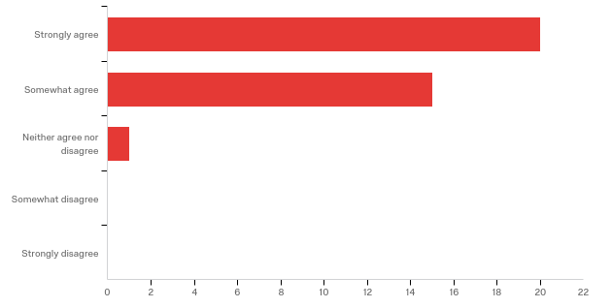

# | Field | Minimum | Maximum | Mean | Std Deviation | Variance | Count
1 | 1. The Workshop sessions explored innovative approaches for hazards and disaster research. | 1.00 | 3.00 | 1.47 | 0.55 | 0.30 | 36

# | Answer | % | Count
1 | Strongly agree | 55.56% | 20
2 | Somewhat agree | 41.67% | 15
3 | Neither agree nor disagree | 2.78% | 1
4 | Somewhat disagree | 0.00% | 0
5 | Strongly disagree | 0.00% | 0
 | Total | 100% | 36

Q2. The Workshop addressed unique opportunities and challenges of hazards and disaster research.
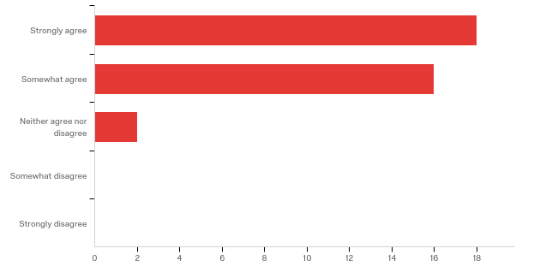

# | Field | Minimum | Maximum | Mean | Std Deviation | Variance | Count
1 | 2. The Workshop addressed unique opportunities and challenges of hazards and disaster research. | 1.00 | 3.00 | 1.56 | 0.60 | 0.36 | 36

# | Answer | % | Count
1 | Strongly agree | 50.00% | 18
2 | Somewhat agree | 44.44% | 16
3 | Neither agree nor disagree | 5.56% | 2
4 | Somewhat disagree | 0.00% | 0
5 | Strongly disagree | 0.00% | 0
 | Total | 100% | 36

Q3. The Workshop participants reflected a diversity of disciplines and perspectives.
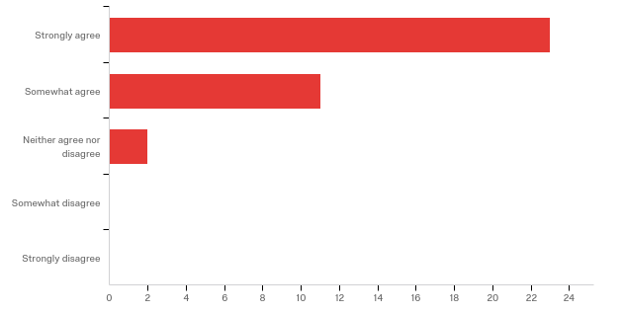

# | Field | Minimum | Maximum | Mean | Std Deviation | Variance | Count
1 | 3. The Workshop participants reflected a diversity of disciplines and perspectives. | 1.00 | 3.00 | 1.42 | 0.60 | 0.35 | 36

# | Answer | % | Count
1 | Strongly agree | 63.89% | 23
2 | Somewhat agree | 30.56% | 11
3 | Neither agree nor disagree | 5.56% | 2
4 | Somewhat disagree | 0.00% | 0
5 | Strongly disagree | 0.00% | 0
 | Total | 100% | 36

Q4. The Workshop provided an opportunity to form new collaborations within or outside my existing network(s).
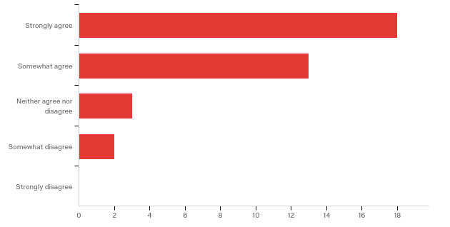

# | Field | Minimum | Maximum | Mean | Std Deviation | Variance | Count
1 | 4. The Workshop provided an opportunity to form new collaborations within or outside my existing network(s). | 1.00 | 4.00 | 1.69 | 0.84 | 0.71 | 36

# | Answer | % | Count
1 | Strongly agree | 50.00% | 18
2 | Somewhat agree | 36.11% | 13
3 | Neither agree nor disagree | 8.33% | 3
4 | Somewhat disagree | 5.56% | 2
5 | Strongly disagree | 0.00% | 0
 | Total | 100% | 36

Q5. The Workshop encouraged me to think about research campaigns in new or different ways.
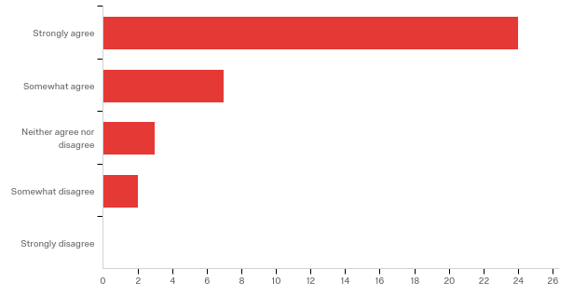

# | Field | Minimum | Maximum | Mean | Std Deviation | Variance | Count
1 | 5. The Workshop encouraged me to think about research campaigns in new or different ways. | 1.00 | 4.00 | 1.53 | 0.87 | 0.75 | 36

# | Answer | % | Count
1 | Strongly agree | 66.67% | 24
2 | Somewhat agree | 19.44% | 7
3 | Neither agree nor disagree | 8.33% | 3
4 | Somewhat disagree | 5.56% | 2
5 | Strongly disagree | 0.00% | 0
 | Total | 100% | 36

Q6. The Workshop encouraged me to think about interdisciplinary teams in new or different ways.
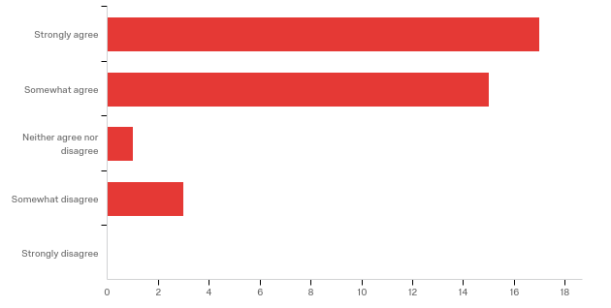

# | Field | Minimum | Maximum | Mean | Std Deviation | Variance | Count
1 | 6. The Workshop encouraged me to think about interdisciplinary teams in new or different ways. | 1.00 | 4.00 | 1.72 | 0.87 | 0.76 | 36

# | Answer | % | Count
1 | Strongly agree | 47.22% | 17
2 | Somewhat agree | 41.67% | 15
3 | Neither agree nor disagree | 2.78% | 1
4 | Somewhat disagree | 8.33% | 3
5 | Strongly disagree | 0.00% | 0
 | Total | 100% | 36

Q10. Please share additional comments, questions, concerns, or suggestions here.

I feel that the discussions did not have a very strong connection to the NHERI sites. For a 5-yr projection, I would like to have experienced more focus on the existing sites. It is important to show connections of completed and expected outcomes to usage of the existing sites.
Great workshop - thank you for organizing it. My somewhat negative comment was about the international aspect. I think NHERI NCO should focus on US first, international efforts second. The connections between US-UK for infrastructure was pretty interesting.
Thank you so much to the entire Workshop Organizing Committee and all of the speakers. It was a great event.
Thank you for an excellent workshop!
I really enjoyed the Day 1 program and Day 2 keynote. However, the theme of the Day 2 breakout session was not clear, and the summary of the breakout session were not so impressive. The summary of the Day 1 breakout sessions and discussion should have been introduced by the moderators so that inter / trans-disciplinary approaches may have been discussed more seriously in the Day 2 breakout.
I think the first day was fantastic but the second not so much. The “leaders” in the sections were not equally prepared and I feel that some of the conversations were quite incremental. On another note and just of courtesy to people from The West Coast, the schedule could have started just a bit later on both days.
Great workshop and very well planned and executed.
I very much appreciated the obvious work put into preparing for this workshop.
There was only one breakout session, which was co-facilitated by social scientists. It is understandable that NHERI is an engineering-based plan. It would be great increase the percentage of social scientists' engagement for facilitating the breakout sessions.
I thought the workshop was extremely informative and helpful! The breakout sessions on disruptive technologies were especially enlightening.. I wish I would have been able to attend them all. I think it would have been beneficial if there were more discussion on how to incorporate the different disruptive technologies into different types of research campaigns (e.g. numerical vs. experimental). I also think it would have been helpful if there was more time set-aside to develop the research campaigns.
It was a very well organized and informative event.
Presentations by junior faculty on current topics did not have enough diversity of topics and depth. Some senior speakers lacked understanding of the connection or possible use of their work to Natural Hazards research.
The workshop was very instructive and gave me many ideas for our future planning of the research infrastructure. I hope NHERI together with NSF to play a leading role to organize an international network of research infrastructures.
For the last question, I think we should be able to check more than one facility. Otherwise, it is very nicely done. Thanks to you and Lori.

APPENDIX 5

Natural Hazards Engineering Research Infrastructure (NHERI)

NHERI is a distributed, multi-user, national network that provides natural hazards engineering, social science, and interdisciplinary communities with state-of-the-art research infrastructure. This handout includes information on the facilities and resources that make up the NHERI network.

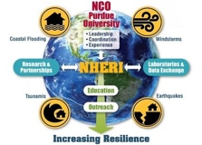
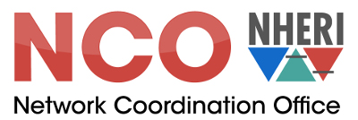
Network Coordination Office (NCO)
NSF Award #1612144
Purdue University
www.designsafe-ci.org/facilities/nco/

The NCO serves as the leader and focal point for NHERI, building a global, multi-hazard, collaborative research community and research infrastructure focused on mitigating the impacts of earthquakes, windstorms, and related hazards of tsunamis and storm surge on civil infrastructure and society.

Wall of Wind
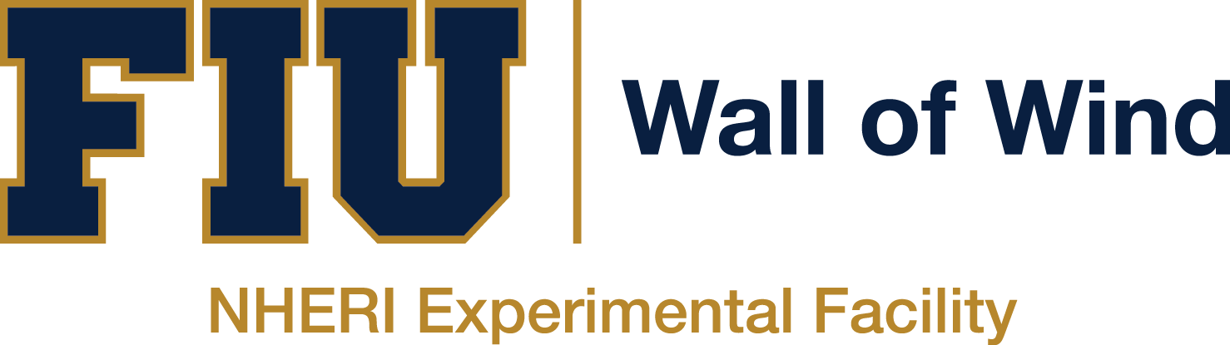
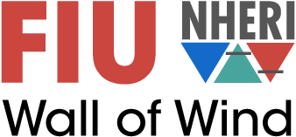
NSF Award #1520853
International Hurricane Research Center
Florida International University
wow.fiu.edu

The Wall of Wind (WOW) is a large open-jet wind tunnel facility with distinct advantages over conventional wind tunnels. WOW enables testing of entire structures at full-scale, leading to performance-based design for hurricanes through direct correlation of wind speed with performance and damage levels.

Real-Time Multi-Directional (RTMD) Natural Hazards Simulation Facility
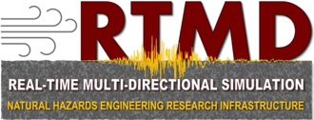
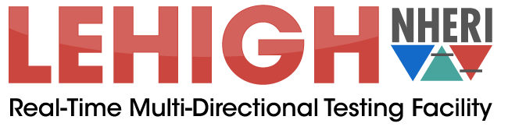
NSF Award #1520765
Lehigh University
lehigh.designsafe-ci.org

The Real-Time Multi-Directional (RTMD) Natural Hazards Facility at Lehigh University is a large-scale structural testing laboratory that has a unique portfolio of equipment, instrumentation, infrastructure, testbeds, experimental simulation control protocols, large-scale simulation and testing experience along with know-how that does not exist elsewhere in the United States. The unique strength of the NHERI Lehigh EF is accurate, large-scale, multi-degree-of-freedom and multi-directional simulations of the effects of natural hazard events on civil infrastructure systems (i.e., buildings, bridges, industrial facilities, etc.). Specifically, the facility has the ability and extensive experience to perform large-scale multi-directional real-time hybrid simulations to investigate the response of entire structures to natural hazards such as earthquakes and wind storms.

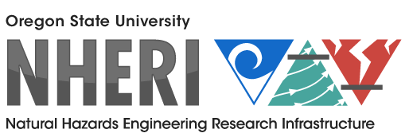
O.H. Hinsdale Wave Research Laboratory Experimental Facility
NSF Award #1519679
Oregon State University
wave.oregonstate.edu

The O.H. Hinsdale Wave Research Laboratory (HWRL) has two specialized large-scale resources for physical model testing of coastal systems subject to the action of tsunamis created by earthquakes and storm surge and waves created by wind storms: the Large Wave Flume (LWF) and the Directional Wave Basin (DWB). Both the flume and basin are capable of generating wind waves and tsunamis. The flume is a two-dimensional representation of the coast (looking directly out to sea), eliminating the complexity of longshore currents and wave direction and allowing a cross-section of test specimens to be studied at a large scale.

Computational Modeling and Simulation Center (SimCenter)
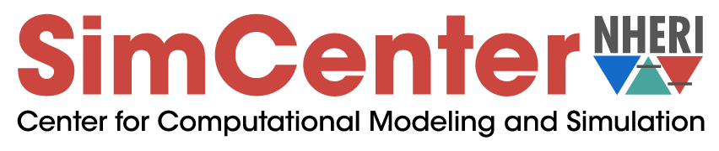
NSF Award #1622843
University of California at Berkeley
simcenter.designsafe-ci.org

The SimCenter provides next-generation computational modeling and simulation software tools, user support, and educational materials to the natural hazards engineering research community with the goal of advancing the nation’s capability to simulate the impact of natural hazards on structures, lifelines, and communities.

Centrifuge Facility
NSF Award #1520581
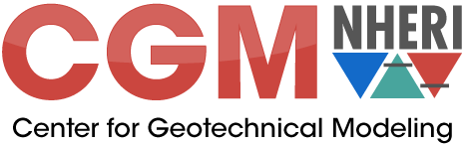
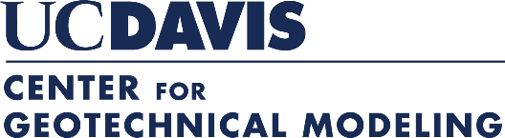
Center for Geotechnical Modeling
University of California at Davis
cgm.engr.ucdavis.edu

The Center for Geotechnical Modeling (CGM) operates 9-m and 1-m radius geotechnical centrifuges equipped with shaking tables for research on soil and soil-structure systems affected by earthquake, wave, wind, and storm surge loadings. Geotechnical centrifuges enable the use of scale models to represent nonlinear, stress-dependent responses of soil. The 9-m radius centrifuge, one of the largest centrifuges equipped with a shaking table in the world, enables researchers to perform experiments with a holistic-level of complexity that is not possible with smaller centrifuges.

Large High-Performance Outdoor Shake Table
NSF Award #1520904
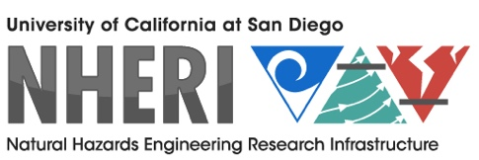
University of California at San Diego
nheri.ucsd.edu/about/contact.shtml

The NHERI Experimental Facility at the University of California, San Diego, provides a large, high performance, outdoor shake table (LHPOST) to support research in structural and geotechnical earthquake engineering. This facility enables seismic testing of extensively instrumented large- or full-scale structural, geotechnical, and soil-foundation-structural systems under extreme earthquake loads to produce the experimental data essential to advancing the science, technology, and practice in earthquake disaster mitigation and prevention.

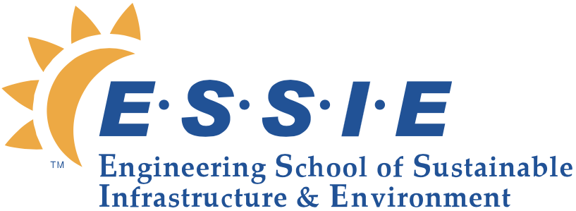
Wind Experimental Facility
NSF Award #1520843
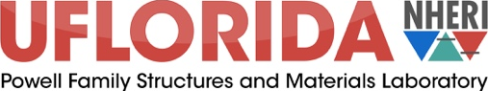
University of Florida
ufl.designsafe-ci.org

The wind experimental facility at the University of Florida provides users access to one of the largest wind engineering experimental research infrastructure facilities in the world. It enables investigators the opportunity to characterize loading on, and dynamic response of, a wide range of infrastructure types in a large, reconfigurable boundary layer wind tunnel (BLWT). Researchers can also conduct full-scale tests on large building systems with equipment capable of ultimate/collapse loads associated with a Simpson Hurricane Wind Scale Category 5 hurricane or an Enhanced Fujita Scale 5 tornado.

DesignSafe Cyberinfrastructure
NSF Award #1520817
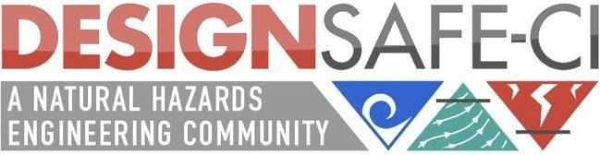
Texas Advanced Computing Center
University of Texas at Austin
DesignSafe-ci.org

DesignSafe is the cyberinfrastructure (CI) platform for NHERI. DesignSafe allows researchers to more effectively share, publish, and find data using the Data Depot data repository; perform numerical simulations using high performance computing via the Discovery Workspace; and integrate diverse datasets across the platform. DesignSafe embraces a cloud strategy — with all data, simulation, and analysis taking place on the server-side resources of the CI, accessible and viewable from the desktop.

Large Mobile Shakers
NSF Award #1520808
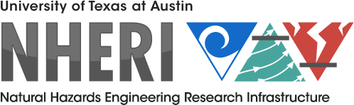
University of Texas at Austin
utexas.designsafe-ci.org

The large mobile shakers in the NHERI@UTexas experimental facility contribute unique, powerful servo-hydraulic shakers and associated dynamic instrumentation to study and develop novel in-situ testing methods that can be used to both evaluate the needs of existing infrastructure and optimize the design of future infrastructure, such that our communities become more resilient to earthquakes and other natural hazards. The mobile shakers provide a unique resource for studies related to subsurface geotechnical imaging, in-situ linear and nonlinear material characterization, and soil-foundation-structure interaction, among other applications.

Natural Hazards Reconnaissance Facility
NSF Award #161820
University of Washington
rapid.designsafe-ci.org

The Natural Hazards Reconnaissance Facility (referred to as the “RAPID Facility") enables the natural hazards and disaster research communities to conduct next-generation rapid response investigations to characterize civil infrastructure performance and community response to natural hazards, evaluate the effectiveness of design methodologies, calibrate simulation models, and develop solutions for resilient communities.

CONVERGE: Coordinated Social Science, Engineering, and Interdisciplinary Extreme Events Research
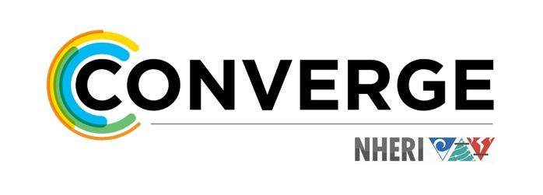
NSF Award #1841338
University of Colorado Boulder
converge.colorado.edu

CONVERGE links social science, engineering, and interdisciplinary extreme events research (EER) networks and NHERI facilities; develops best practices for the ethical conduct of research; and promotes natural hazards research to reduce vulnerability. CONVERGE supports the Leadership Corps for rapid response research and develops training modules and briefing sheets for researchers from various disciplinary backgrounds. A partnership with DesignSafe is culminating in a novel social science and interdisciplinary data model, and a collaboration with the RAPID Facility is accelerating the social science and interdisciplinary components of the RAPIDApp. CONVERGE is also the home of the Social Science Extreme Events Research (SSEER) and Interdisciplinary Science and Engineering Extreme Events Research (ISEEER) networks.

